**A STUDY ON VENEZUELA INFLATION**

Visakhapatnam

A Project Report submitted in partial fulfilment for the award of

MBA (Fintech)

Submitted by

A.BalajiRegd No: 121923901002

K.Amman Naidu Regd No:121923901004

G.Kumari Regd No: 121923901006

P.Sai Pratyusha Regd No: 121923901008

Under the guidance of

Mr Leben Johnson Mannariat

Assistant Professor



GITAM INSTITUTE OF MANAGEMENT

GITAM UNIVERSITY

(U/s 3 of UGC Act)

VISAKHAPATNAM

(2019-21)

**DECLARATION**



We, the undersigned, hereby declare that, the project titled “Venezuela inflation” submitted to GITAM Institute of Management, GITAM University for the award of the Masters of Business Administration (Fintech) is the original work done by us, under the guidance of Mr Leben Johnson Mannariat, GITAM Institute of Management. The empirical findings in this report are based on the given data. It was not copied from any other project. The project has not been submitted to any Substitute/University for the award of any Diploma/Degree.

A.Balaji Regd No: 121923901002

K.Amman Naidu Regd No: 121923901004

G.Kumari Regd No: 121923901006

P.Sai Pratyusha Regd No: 121923901008

**CERTIFICATE**

This is to certify that the project entitled, “Venezuela inflation” is a bonafide work done by A.Balaji(121923901002),K.AmmanNaidu(121923901004),G.Kumari(121923901006),P.Sai Pratyusha(121923901008)**,** and is submitted in partial fulfilment for the Masters of Business Administration(Fintech) of GITAM University. It has not been submitted for the award of any diploma/degree in any other Institution/University.

Date: Mr. Leben Johnson Mannariat

Place: Visakhapatnam

**ACKNOWLEDGEMENT**

We are thankful to Mr. Leben Johnson Mannariat, Assistant Professor and the project guide who helped me and guided me in completing this project.

Thankful to each member of our team and the respondents who have guided us at every stage in preparing and finishing this project with their valuable suggestions.

A.Balaji Regd No: 121923901002

K.Amman Naidu Regd No: 121923901004

G.Kumari Regd No: 121923901006

P.Sai Pratyusha Regd No: 121923901008

**CONTENTS**

**Title page No.**

1. Introduction 8

2.Impact on GDP 9

2.1 GDP measurements 10

2.2 consumer confidence 14

2.3 consumer spending 15

2.4 Venezuela government spending 16

2.5 Venezuela government budget 17

2.6 Venezuela government debt to GDP 17

2.7 Venezuela government military expenditure 18

2.8 Venezuela industrial production 19

2.9 Venezuela steel production 19

2.10 Venezuela GDP forecast 20

3.Impact on labour 20

3.1 Industry shutdown 21

3.2 exodus 22

3.4 poverty and workers 23

3.4 Health Impact 24

4.Unemployment rate 24

4.1 causes of unemployment in Venezuela 26

4.2 unemployment persons 26

4.3 Growth effecting unemployment 27

5.Emplyment rate 28

5.1 Employed persons 29

5.2 minimum wages 29

6.venzezuela currency 30

7.venezuela protests and crisis 34

7.1 2017 Venezuean consitituent assembly election 35

7.2 2018 Venezuean presidential election 36

8.Culture 38

8.1 cusine 38

8.2 clothing 39

8.3 religion in Venezuela 40

8.4 literature and threats 40

8.5 sports 41

8.6 life in Venezuean society 41

9.sanctions of Venezuela 42

10.impact of sanctions 47

11. Imports & exports 54

12.Impact on inflation 57

12.1 lifeblood of oil 56

12.2 causes 59

13.impact on trade 64

13.1 exports 64

13.2 imports 66

13.3 trade balance 68

14.Impact on growth rate 68

14.1 solutions and adaptions 70

15. How Venezuela is overcoming sanctions 71

16. Austerity measures 72

17.Conclusion 76

**Introduction**

In the year 1920 Venezuela has highest oil reserves in the world where Venezuela became the one of top 10 richest country in the world, So countries across the world came to Venezuela to establish their oil private companies in Venezuela and Venezuela government has decided to collect 50% of taxes from their profits.

Then Government start investing the money which come from taxes to build the infrastructure for the development of country, but still in Venezuela 30% of the population still remains in poverty due to government spends the money only in infrastructure projects. So Venezuela people start fighting against government for not spending the money that has come from taxes to poor and labour people and in the year 1999 **Hugo Chavez** has elected as the president of Venezuela.

After Hugo Chavez elected as president of Venezuela, he started investing the money to the poor people giving subsidies like free food, clothes, shelter, education, health, current and petrol and stop investing on infrastructure projects and it leads to decreasing the 20% of poor people in the country. So when government is giving everything as free subsidies the private investors and private shops has shut down leads to increase in corruption and black market.

Farmers stop cultivating and fielding their lands where out of labour force increases and people start importing the food from other countries where Unemployment increases. Then Venezuela government start buying the private petrol companies which are owned by government leads to decrease in oil competitors. In the year 2013 Hugo Chavez dead and Nicolas Maduro has elected as a new president of Venezuela where he repeated the same mistake giving subsides and in the year 2014 oil price has come down and government cannot be able to give the salary to the people and no investors, food and consumer has no money to spend

Imports increases and oil exports are there but there is no enough money to spend for the country and slowly it leads to Inflation and later on Hyperinflation.

**2.Impact on GDP**

GROSS DOMESTIC PRODUCT (GDP):- The gross value of all finished goods and services within the country and within the given period of time.

|  |
| --- |
| Country |

|  |  |  |
| --- | --- | --- |
| Domestic |  | International |

|  |  |  |  |  |
| --- | --- | --- | --- | --- |
| Consumer | Investor | Government | Exports | Imports |

**GDP=C+I+G+X-M**

Where,

C=CONSUMER,

I=INVESTER,

G=GOVERNMENT,

X-M=EXPORTS-IMPORTS.

It is a measure of national income, national output, and national expenditure in a particular country. It is the most popular method of measuring an economy’s output and it is therefore considered a measure of the size of the economy. When any one says economy is larger than another or that an economy is growing or shrinking usually that are referring to GDP figures.

GDP is defined as all consumption by households all investment by business and all purchases by the government, plus purchases made by foreigners minus purchases of things made by abroad.

GDP is important because it gives a bird’s eye view of how an economy is doing. If GDP speeds up it can be a sign that good things are happening or are about to happen in a number of areas people getting more jobs or better pay or business feeling confident enough to invest

more. It’s not a complete picture of a national economy by any means, but it’s a good start of a quick summary.

GDP provides an economic snapshot of a country, used to estimate the size of an economy and growth rate. Through it has limitation GDP is a key tool to guide policymakers, investors, and business in strategic decision making.

GDP can be calculated in three ways using expenditure, production, income, so that it can be adjusted for inflation and population to provide deeper insights.

**2.1 GDP Measurements**

1. rrrNominal GDP
2. Real GDP
3. GDP Growth Rate
4. GDP Per Capita
5. **Nominal GDP: -** Nominal GDP is GDP evaluated at current market prices. Therefore, nominal GDP will include all of the changes in market prices that have occurred during the current year due to inflation. It is the measurement of raw data. Venezuela's

Nominal GDP reached 20,139.5 USD bn in Dec 2017, compared with 3,035.9 USD bn in the previous year.

In Venezuela every year the product cost increases comparing to productivity from 2012 onwards so it leads to increases in the nominal GDP. Now they are no able to buy the basic goods like food and water.

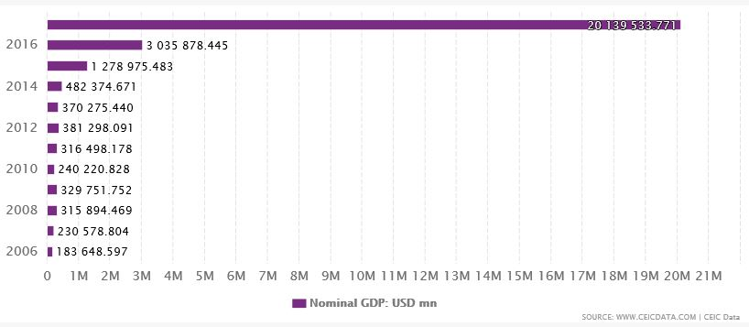

Table1:- Nominal GDP

**2**. **Real GDP: -** Real GDP is an inflation adjusted measure that reflects the value of all goods and services produced by an economy in a given year, expressed in base year prices. Real GDP is a measure of a country’s total economic output that is adjusted for price changes. It takes account the impact of inflation and allows comparison of economic output for one year to the next and other comparisons over period of time.

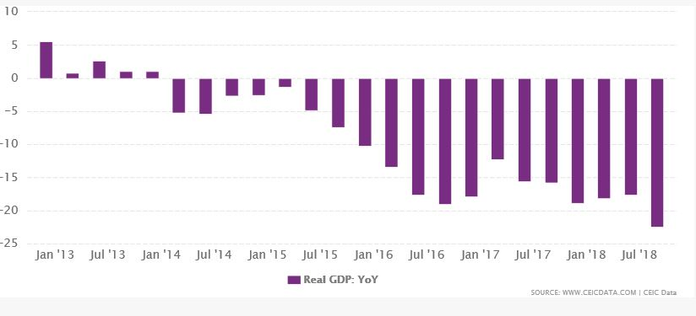

Table2:- real GDP

**Nominal GDP vs. Real GDP**

GDP is based on monetary value of goods and services, it is subject to inflation. Rising prices will tend to increases GDP look smaller, without necessarily reflecting any change in the quantity or quality of goods and services produced. Thus, just by looking at an economy’s un-adjusted GDP, it is difficult to tell whether the GDP went up as a result of production expanding in the economy or because prices rise.

That’s why economists have come up with an adjustment for inflation to arrive at an economy’s REAL GDP. By adjusting the output in a given year for the price levels that prevailed in a reference year, called the base year, economist adjusts for inflation impact. This way, it is possible to compare a country’s GDP from one year to another and see if there is any real growth.

REAL GDP is calculated using a GDP price deflator, which is the difference in prices between the current year and the base year.

**3. GDP Growth Rate: -** The GDP Growth Rate measures how fast the economy is growing. It does this by comparing one quarter of the country’s gross domestic product to the previous quarter. GDP measures the economic output of a nation.

The GDP growth rate is driven by the four components of GDP. The main driver of GDP growth is personal consumption. This includes the critical sector of retail sales. The second component is business investment, including construction and investment levels. Government spending is the third driver of growth. Its largest categories are social security benefits, defence spending, and Medicare benefits. The government often increases spending to jump-start the economy during recession. Fourth is net trade. It may increases or decreases in GDP from quarter to quarter.

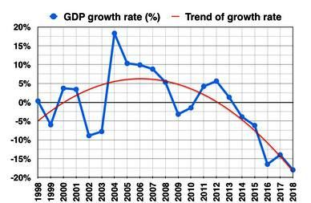

**4. GDP Per Capita**: - Real GDP PER CAPITA is a measurement of the total economic output of a country divided by a number of people and adjusted for inflation. It’s used to compare the standard of leaving between countries and over time.

This economic indicator consists of the following three concepts. The first concept is Gross Domestic Product that measures everything that a country produces in a year. The components of GDP are personal consumption business investment, government spending, and exports minus imports. The bureau of economic analysis reports it quarterly, updating its estimates each month. The second is REAL GDP which is GDP without the effect of price changes. Inflation makes regular, NOMINAL GDP higher, so REAL GDP is a more accurate

measurement when you want to compare an economy over time. The third is PER CAPITA which means PER PERSON. REAL GDP is divided by the population of a country to calculate REAL GDP PER CAPITA. It’s the best way to compare economic indicators like GDP for countries with very different population sizes. It measures GDP per person in the national populace it is used to compare data between various countries.

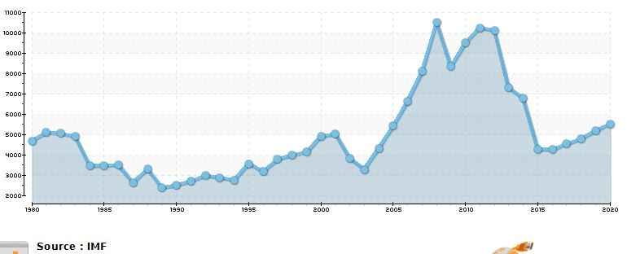

**2.2 Consumer confidence**

Consumer confidence is an economic indicator that measures the degree of optimism that consumers feel about the overall state of the economy and their personal financial situation. Consumer confidence is an economic indicator, their confidence impacts their economic decisions like spending activity so that it results a key indicator for the overall shape of the economy. Consumer confidence usually increases when economy expands.

Consumer Confidence in Venezuela increased to 80 Index Points in the second quarter of 2019 from 72 Index Points in the first quarter of 2019. Consumer Confidence in Venezuela averaged 70.13 Index Points from 2011 until 2019.

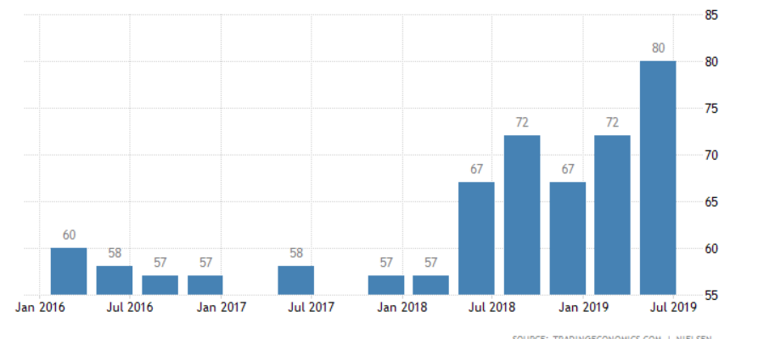

**2.3 Consumer Spending**

## Consumer spending is the acquisition of goods and services by individual or families. It is the largest part of aggregate demand of the macroeconomic level. Consumer spending is an important economic factor it usually coincides with the overall consumer confidence in a nation’s economy. High consumer confidence indicators usually relate to higher levels of consumer spending in the economic market.

## Consumer Spending in Venezuela decreased to 5038 VEF (Venezuelan Bolivar Fuerte) Million in the third quarter of 2018 from 5651 VEF Million in the second quarter of 2018. Consumer Spending in Venezuela averaged 8038.78 VEF Million from 1998 until 2018, and the highest is 12336 VEF Million in the fourth quarter of 2013 and a lowest is 4886 VEF Million in the first quarter of 2003.

## 

**2.4 Venezuela Government spending**

## Government Spending in Venezuela increased to 2040 VEF (Valsts elektrotehniska fabrika) Million in the third quarter of 2018 from 1728 VEF Million in the second quarter of 2018. Government Spending in Venezuela averaged 2101.86 VEF Million from 1998 until 2018, reaching an all-time high of 3645 VEF Million in the fourth quarter of 2014 and a record low of 1069 VEF Million in the second quarter of 1999.

## 

**2.5 Venezuela Government Budget**

Venezuela recorded a government budget deficit equal to 20percent of the country GDP in 2015. Government Budget in Venezuela averaged -3.41% of GDP from 1990 to 2015, reaching an all time high as 3.79% of GDP in 1991 and a low of -20% of GDP in 2015.

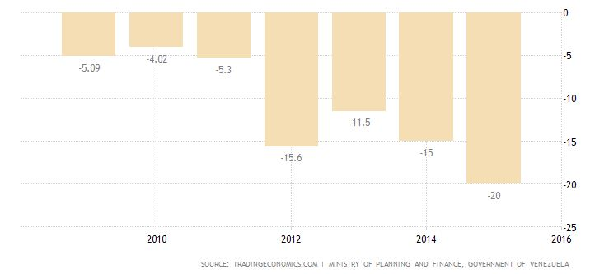

**2.6 Venezuela Government Debt to GDP**

Venezuela recorded a government debt equivalent to 23% of the country GDP in 2017. Governmeent debt to GDP in Venezuela averaged 42.39% from 1994 to 2017, reaching an all time high of 72.30% in 2013 and a low record of 20.30% in 2008

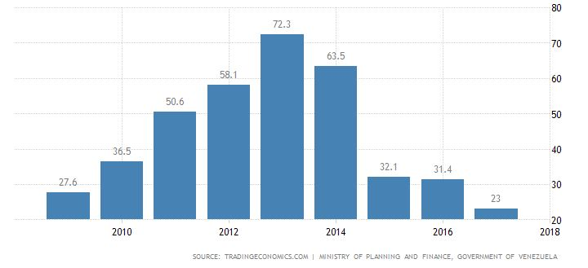

**2.7 Venezuela Military Expenditure**

Military exe4penditure in Venezuela increased to 465USD Million in 2017 from 389 USD Million in 2016. Military expenditure in Venezuela averaged 846.67 USD Million from 1955 until 2017, reaching an all time high 1852 USD Million in 2017 and low a record of 200 USD Million in 1961.

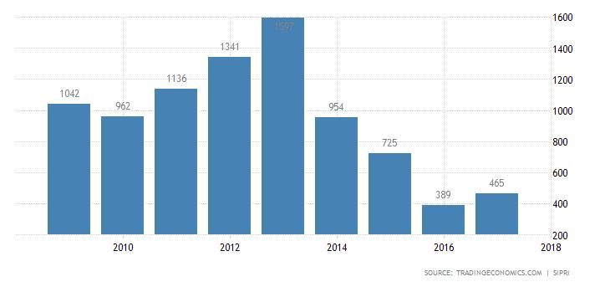

**2.8 Venezuela Industrial Production**

Industrial Production in Venezuela decreased 20.60% in January 2019 over the same month in the previous year. Industrial production averaged -3.02% from 1998to 2019, reaching all time high of 183.50% in December of 2003 and a low record of -64.90% in December of 2002.

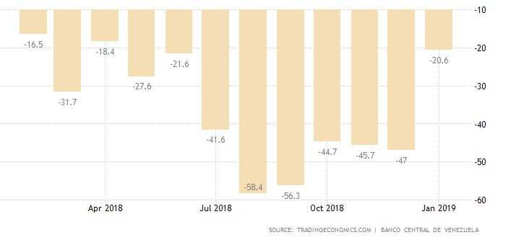

**2.9 Venezuela Steel Production**

Steel production in Venezuela increased to 5 Thousand Tons in July from 3 Thousand Tons in June of 2019. Steel production in Venezuela averaged 253.59 Thousand Tons from 1980 to 2019, reaching an all time high of 479 Thousand Tons on in march of 2007 and a record low of 3 Thousand Tons in June 2019

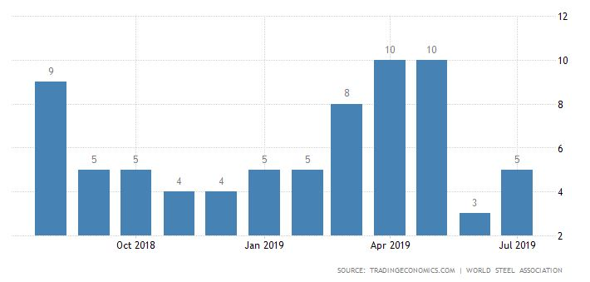

**GDP Forecast**

GDP Annual Growth Rate in Venezuela is expected to be -26.00 percent by the end of this quarter, according to Trading 4Economics global macro models and analysts expectations.

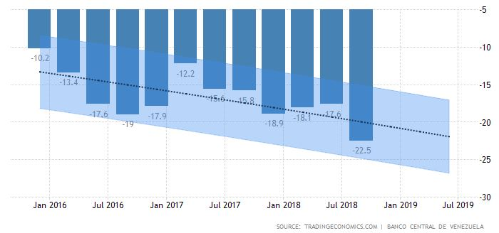

**3.Impact on Labour**

Venezuela, the country with the largest oil reserves in the world, is facing the worst economic, social and political crisis in its history, which has affected the quality of life of the workforce and the entire population.

They are 32 million people living in Venezuela, almost half of the people are working (13,100,203 people have some sort of occupation), and all of them and their family members are being affected in different ways by the current economic climate. Over the last decade, the crisis has reached its peak, bringing the lowest salaries in the world, hyperinflation levels of 130% inter-monthly severe shortages in food, medicine, auto parts and other kinds of goods. It is now common to see long lines of people, as well as ‘bachaqueros’ in the streets of Venezuela in their quest to obtain the subsidized food.

‘Bachaqueros’, an informal worker’s phenomenon, resell subsidized products on the black market with prices up to 100 times its value, causing an incalculable loss to the treasury in tax revenues.

The declining economy and highly dangerous environments have significantly decreased the quality of life for Venezuelan workers and their families, to the point where no longer home or workplaces are safe places.

Venezuela macroeconomic changes have negatively affected the development of this South American nation, in clear contradiction with its abundant oil reserves. Venezuela has certified 302.25 billion barrels of oil, thus being the most important country in the world oil context.

Venezuela possesses 24.8% of the world’s proven oil reserves, which makes it the country with the largest reserves on the planet. Its economy mainly depends on its revenues from the oil industry, which represent 96% of its exports volume and 11.6% of its GDP. The industry is led by the huge state-oil company.

**3.1 Industry shutdowns**

The fall in foreign currency caused import levels to drop and because the demand for foreign currency had dropped, because the government institution (CENCOEX) has not covered the demand required. CENCOEX (Centro Nacional de Comercio Exterior) it is for National Centre for Foreign Commerce.

Venezuela Central Bank show that imports fell 44.21%, from USD 61,591.00 million in 2013 to USD 36,591.00 million in 2014. In December 2016, President Maduro announced that imports had dropped to USD 17,800.00 million, a 50% decrease since its all-time high of 2014.

Multinational companies that used to have their main production sites for Latin America located in Venezuela, have not escaped the problematic. Companies such as Kimberly Clark, General Motors, Bridgestone, Clorox, Cemex, Ford Motors and General Mill’s have either been taking over by the government, permanently shut down their business in Venezuela, or temporarily paralyzed operations. From the year 2015, more than 14 airlines have ceased operations, leaving Venezuelans with very few remaining options to travel abroad. Although numbers for lost jobs have not been quantified, it is estimated that more than 50,000 direct jobs and 200,000 indirect jobs have been lost by these shutdowns.

In 2002 there were approximately 830,000 active companies. Today, fewer than 250,000 remain operational and mainly due the adverse macro-economic conditions and the inability to access foreign currency to acquire raw materials, machinery and equipment in inter- national markets

**3.2 Exodus**

More than 3 million Venezuelans have left the country since 2015. For a country of over 32 million people, this represents 5% of the entire population. Every day, Thousands of people are crossing the borders hoping to reach other South American countries, engaging in journeys that may last for more than 10 days, by land transportation and by foot, carrying a suitcases with their most personal belongings.

Migrants claim they are fleeing the country as a result of the socio-economic situation, including hyperinflation, violence, food and medicines scarcity, collapse of essential social services as well as virtually inexistent wages.

**3.3 Poverty and workers**

Venezuela being considered a privileged and “rich in resources” country, its poverty levels has reached 87% in the year 2017 and in that half of the population living under extreme poverty (61.2%) poverty has almost doubled since 2014, going from 48% to 87% Extreme poverty in 2014 was at 23.6%, and by 2017 increased to 61.25%

In Venezuela 23 million people have trouble meeting their needs through their regular income. For the first time, extreme poverty is higher than non-extreme poverty; more than half of the country’s population does not have enough income to meet their basic food needs.

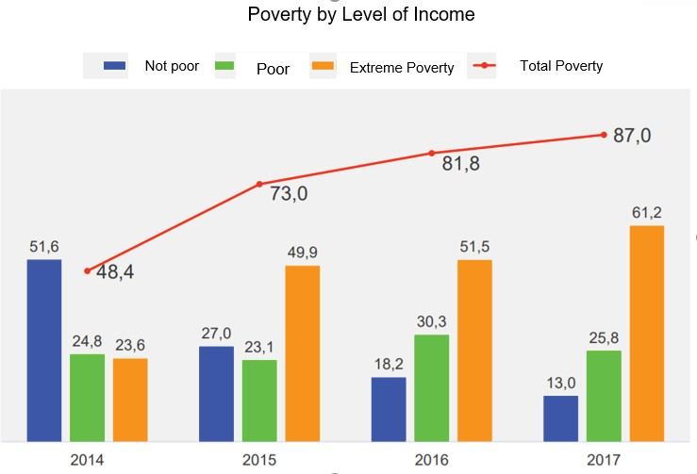

A common indicator used worldwide for measuring poverty is the access to basic services like water, gas, electricity and telecommunications. In Venezuela water and electricity shortages which have lasted several months, due to problems in the maintenance of equipment and unfavorable weather conditions. Several industries have reported important deficits in their production due electricity shutdown and a lack of water supply. Internet and telephone services in Venezuela have been ranked as the worst in all Latin America.

**3.4 Health impact**

Venezuelan health system is collapsing. And it is facing a nationwide crisis of its medical care system. The Venezuelan Pharmaceutical Federation has reported shortages in 80% of medical supplies. Additionally, Venezuela is struggling with outbreaks of measles, diphtheria, and malaria.

Medical services are very unstable, which is particularly noticeable in public facilities. Access to medicines is strictly controlled by the government, and their availability is difficult to predict. Adequate health care is currently not available through the public health system in Venezuela.

If health is defined by the World Health Organization (WHO), as a state of complete physical, mental, and social well-being and not merely the absence of disease, anyone living in Venezuela could not be completely healthy body with the scarcity of basic products and goods, limited access to medication and health care, low purchasing power, violence, instability, inflation, and uncertainty.

1. **Unemployment Rate**

Unemployment rate measures the number of people actively looking for a job as a percentage of the labour force and current Unemployment Rate in Venezuela increased to 7.30 percent in April from 7.10% in March of 2016. Unemployment Rate in Venezuela averaged 10.62% from 1999 until 2016, reaching an all time high of 20.70 % in February of 2003 and a record low of 5.50% in December of 2014.

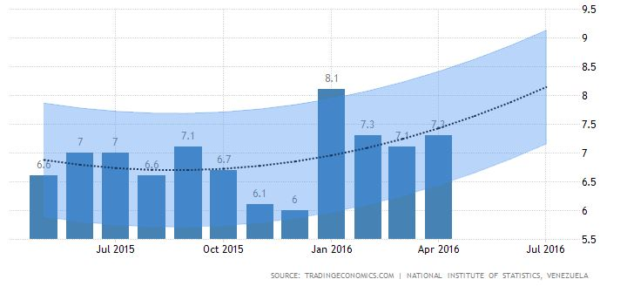

venezuela, which despite its oil wealth is suffering deep recession, triple-digit inflation and chronic shortages.According to Consecomercio, a major retail industry group, Venezuela in the past 18 months lost close to 1 million private sector jobs.

“Who is creating jobs? Nobody,” said Consecomercio Vice President Alfonso Riera. “That unemployed population unfortunately is migrating to the street, informal work or worse.”

Government critics say nationalizations of businesses and more than a decade of price and currency controls have crippled private enterprise, but President Nicolas Maduro says Venezuela is a victim of an “economic war” led by business leaders with U.S. help.

Union sources said major companies such as food and beermaker Polar, carmaker Ford and bottler Cola-Cola Femsa all are reducing their workforce by negotiating redundancies and offering employees buyouts.

“People are taking the packages,” said JhonnyMagdaleno, who leads a Polar union. He said workers were being offered the equivalent of $2,500 at the black market exchange rate.

“Production has fallen too much,” he said. “The workers who are left are making 4,000 bolivars weekly ($1 at the black market rate). That doesn’t even enable them to buy a pack of flour.”

**4.1 Causes of Unemployment in Venezuela**

Economic war on Venezuela ,failing of oil prices in international markets ,international sanctions and countries business elite .critics of Venezuela government say the cause is "years of economic mismanagement, and corruption".

Late socialist leader Hugo Chavez reformed labor regulations to reduce hours, extend maternity leave and make dismissals almost impossible. Maduro, his successor and a former union activist, has continued that.

**4.2 Unemployed Persons**

## The number of unemployed persons in Venezuela increased to 1035238 in April of 2016 from 1000943 in March of 2016. Unemployed Persons in Venezuela averaged 1289048.40 from 1999 until 2016, reaching an all time high of 2406251.00 in February of 2003 and a record low of 760063.00 in November of 2008.

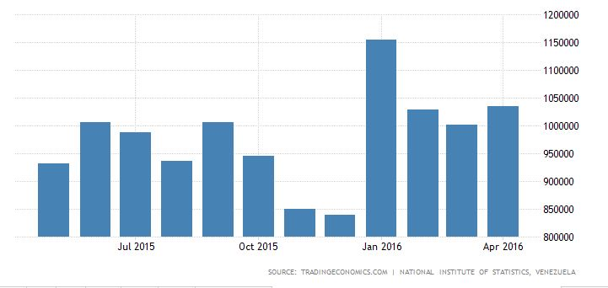

**Growth effecting unemployment**

The reduction in the unemployment rate in the Bolivarian Republic of Venezuela from the highs reached in 2002 (16.2%), 2003 (19.2%) and 2004 (16.6%) was triggered by the large-scale layoff of workers from Petróleos de Venezuela ordered by the government, which led to an 8.4% contraction of gross domestic product (GDP) in a six-month period. Oddly enough, the apparent reduction in unemployment was coupled with a considerable slowdown in the economy, according to the Central Bank of Venezuela. This downturn was so sharp that the economy witnessed negative growth rates, despite the biggest and longest-lasting surge in oil prices ever recorded.

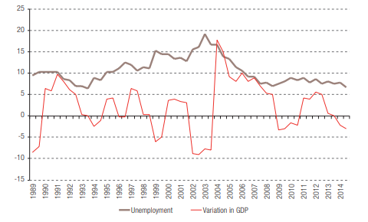

Source: National Institute of Statistics and Central Bank of Venezuela

There is an evident contradiction in the trends of these two variables, since an expansion in economic activity is generally required in order to cut unemployment. Simultaneous reductions in unemployment and GDP growth can be accounted for in a number of ways:

1. The presence of hidden unemployment, which occurs when a large percentage of unsuccessful job-seekers become so discouraged that they stop looking for work and thus are no longer part of the workforce.
2. The use of the informal sector as an escape valve (when this occurs, people are no longer unemployed but the value of their productive effort is not captured in national accounts).

(iii) A combination of these two phenomena. The aim of this study is to take a closer look at these three possible explanations and to use household survey data from INE for the four six-month periods in 2012-2013 to estimate how long, on average, job-seekers remain unemployed.

**5.Employment Rate**

## Employment Rate in Venezuela decreased to 92.67 percent in April from 92.92 percent in March of 2016. Employment Rate in Venezuela averaged 89.37 percent from 1999 until 2016, reaching an all time high of 94.47 percent in December of 2014 and a record low of 79.30 percent in February of 2003.

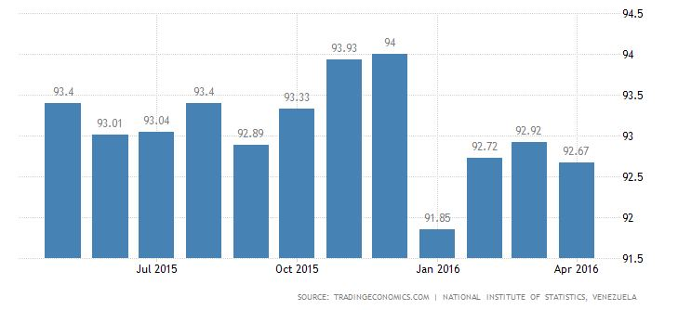

**5.1 Employed Persons**

## The number of employed persons in Venezuela decreased to 13089081 in April of 2016 from 13127644 in March of 2016. Employed Persons in Venezuela averaged 11163967.01 from 1999 until 2016, reaching an all time high of 13607057 in December of 2014 and a record low of 8505814 in February of 2000.

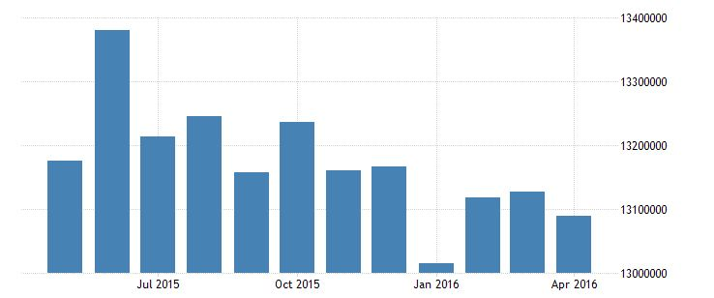

**5.2 Minimum Wages**

## Minimum Wages in Venezuela increased to 4000000000 VEF/Month on April 16th from 180000000 VEF/Month in January, according with the decree published in the Official Gazette. It is the second hike this year. In 2018, the minimum wage was raised five times. Minimum Wages in Venezuela averaged 109178051.92 VEF/Month from 1989 until 2019, reaching an all time high of 4000000000 VEF/Month in April of 2019 and a record low of 4 VEF/Month in January of 1989.

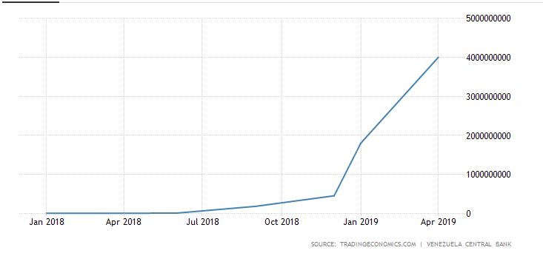

**6.Venezuela currency**

The Bolivar is named after the hero of Latin American independence [Simon Bolivar](https://en.m.wikipedia.org/wiki/Sim%C3%B3n_Bol%C3%ADvar). The bolivar was adopted by the monetary law of 1879, replacing the [venezolano](https://en.m.wikipedia.org/wiki/Venezuelan_venezolano) at a rate of five bolivars to one venezolano. Initially, the bolivar was defined on the [silver standard](https://en.m.wikipedia.org/wiki/Silver_standard), equal to 4.5 g fine silver, following the principles of the [Latin Monetary Union](https://en.m.wikipedia.org/wiki/Latin_Monetary_Union). The monetary law of 1887 made the gold bolivar unlimited [legal tender](https://en.m.wikipedia.org/wiki/Legal_tender), and the [gold standard](https://en.m.wikipedia.org/wiki/Gold_standard) came into full operation in 1910. Venezuela went off gold in 1930, and in 1934.

The bolivar exchange rate was fixed in terms of the [U.S. dollar](https://en.m.wikipedia.org/wiki/U.S._dollar) at a rate of 3.914 bolivars = 1 U.S. dollar, revalued to 3.18 bolivars = 1 U.S. dollar in 1937, a rate which lasted until 1941. Until 18 February 1983 (now called Black Friday (Viernes Negro) by many [Venezuelans](https://en.m.wikipedia.org/wiki/Venezuela)) the bolivar had been the region's most stable and internationally accepted currency.

The government announced on 7 March 2007 that the bolivar would be revalued at a ratio of 1,000 to 1 on 1 January 2008 and renamed the bolivar Fuerte in an effort to facilitate the ease of transaction and accounting. The newer name is literally translated as "strong bolivar" but is also a reference to an old coin called the peso Fuerte worth 10 [Spanish reales](https://en.m.wikipedia.org/wiki/Spanish_real). The name "bolivar Fuerte" is used to distinguish it from the older currency that was being used along with the bolivar Fuerte.

On 8 January 2010, the value was changed by the government from the fixed exchange rate of 2.15 bolivars Fuertes to 2.60 bolivars for some imports (certain foods and healthcare goods) and 4.30 bolivars for other imports like cars, petrochemicals, and electronics. On 4 January 2011, the fixed exchange rate became 4.30 bolivars for US$1.00 for both sides of the economy. On 13 February 2013 the bolivar Fuerte was devalued to 6.30 bolivars per US$1 in an attempt to counter budget deficits. On 18 February 2016, President Maduro used his newly granted economic powers to devalue the official exchange rate of the bolivar Fuerte from 6.3 Bs.F per US$1 to 10 Bs.F per US$1, which is a 37% [depreciation](https://en.m.wikipedia.org/wiki/Currency_appreciation_and_depreciation) against the U.S. dollar. The bolivar Fuerte entered [hyperinflation](https://en.m.wikipedia.org/wiki/Hyperinflation) in November 2016

In May 2018, the government required prices to be expressed in both bolivars Fuertes and bolivars Soberanos at the then-planned rate of 1,000 to 1. For example, one kilogram of pasta was shown with a price of BsF. 695,000 and BsS. 695. Prices expressed in the new currency were rounded to the nearest 50 centimos as that was expected to be the lowest denomination in circulation at launch

The change in currency was originally scheduled for June 4, 2018. The President delayed the planned June launch date of the bolivar soberano, "the period established to carry out the conversion is not enough". The revaluation was rescheduled to 20 August 2018, and the rate changed to 100,000 to 1, with prices being required to be expressed at the new rate starting 1 August 2018.

On 20 August 2018, the Maduro government launched the new bolivar soberano currency with one bolivar soberano worth 100,000 bolivars Fuertes. New coins in denominations of 50 centimos and 1 bolivar soberano, and new banknotes in denominations of 2, 5, 10, 20, 50, 100, 200 and 500 bolivars soberano were introduced. Under the country's official [fixed exchange rate](https://en.m.wikipedia.org/wiki/Fixed_exchange-rate_system) to the US dollar the new currency was [devalued](https://en.m.wikipedia.org/wiki/Devalued) by roughly 95% compared to the old bolivar Fuerte. The day was declared a bank holiday to allow the banks to adjust to the new currency. Initially, during a transition period the bolivar soberano was to be run alongside the bolivar Fuerte. However, from the start of the transition, on 20 August, bolivar Fuerte notes of 500 and less could not be used only deposited at banks

Additionally, the bolivar soberano is supposed to have a fixed exchange rate to the [petro crypto currency](https://en.m.wikipedia.org/wiki/Petro_(cryptocurrency)), with a rate of 3,600 bolivar soberano to one petro. The petro is supposedly tied to the price of a barrel of oil (about US$60 in August 2018). As of the end of August 2018, there is no evidence that the crypto currency is being traded. Petro is regarded by many as a scam.

|  |  |  |  |
| --- | --- | --- | --- |
| [Venezolano](https://en.m.wikipedia.org/wiki/Venezuelan_venezolano) Reason: unification of circulating currencies Ratio: ​1⁄5 venezolano = 1 bolivar | Currency of Venezuela  31 March 1879 – 31 December 2007 | | Succeeded by: [Bolivar Fuerte](https://en.m.wikipedia.org/wiki/Venezuelan_bol%C3%ADvar#Bol%C3%ADvar_fuerte) Reason: inflation Ratio: 1000 bolivars = 1 bolivar Fuerte |
| [Bolívar](https://en.m.wikipedia.org/wiki/Venezuelan_bol%C3%ADvar#Bol%C3%ADvar) Reason: inflation Ratio: 1000 bolivars = 1 bolivar Fuerte | Currency of Venezuela  1 January 2008 – 20 August 2018 | | Succeeded by: [Bolívar soberano](https://en.m.wikipedia.org/wiki/Venezuelan_bol%C3%ADvar#Bol%C3%ADvar_soberano) Reason: [hyperinflation](https://en.m.wikipedia.org/wiki/Hyperinflation_in_Venezuela) Ratio: 100,000 bolivars Fuertes = 1 bolivar soberano |
| Preceded by: [Bolívar Fuerte](https://en.m.wikipedia.org/wiki/Venezuelan_bol%C3%ADvar#Bol%C3%ADvar_fuerte) Reason: [hyperinflation](https://en.m.wikipedia.org/wiki/Hyperinflation_in_Venezuela) Ratio: 100,000 bolivars Fuertes = 1 bolivar soberano | | Currency of Venezuela  20 August 2018 – present | |

This table shows foreign exchange rate of the Venezuelan bolivar to one [US Dollar](https://en.m.wikipedia.org/wiki/United_States_dollar) between 2012 to 2019.

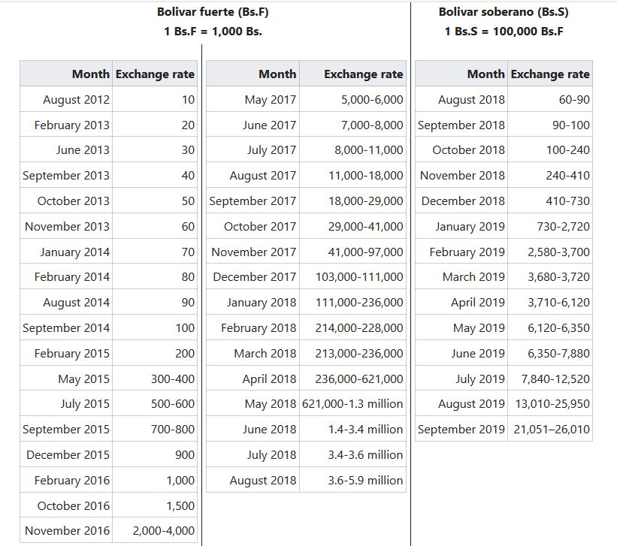

At the supermarket, one litre of milk cost 4,200 bolivars or 11% of his monthly salary of a highly paid professor. Meanwhile, 1kg of milk powder cost 19,995 bolivars almost half of his salary.

**7. Venezuela Protest & Crisis:**

During crisis of Venezuela many governments sanctioned against the people associated with the administration of [Nicolas Maduro](https://en.wikipedia.org/wiki/Nicol%C3%A1s_Maduro). Sanctions were in response to repression during the [**2014 Venezuelan protests**](https://en.wikipedia.org/wiki/2014_Venezuelan_protests)and the [**2017 Venezuelan protests**](https://en.wikipedia.org/wiki/2017_Venezuelan_protests), and activities during the [2**017 Venezuelan Constituent Assembly election**](https://en.wikipedia.org/wiki/2017_Venezuelan_Constituent_Assembly_election) and the [**2018 Venezuelan presidential election**](https://en.wikipedia.org/wiki/2018_Venezuelan_presidential_election). Sanctions were placed on current and former government officials, including members of the [Supreme Tribunal of Justice](https://en.wikipedia.org/wiki/Supreme_Tribunal_of_Justice_(Venezuela)) (TSJ) and the [2017 Constituent National Assembly](https://en.wikipedia.org/wiki/2017_Constituent_National_Assembly)(ANC), members of the military and security forces, and private individuals accused of being involved in human rights abuses, corruption, degradation in the rule of law and repression of democracy.

# 2014 Venezuela protest:

* In 2014, a series of protests, political demonstrations, and civil insurrection began in [Venezuela](https://en.wikipedia.org/wiki/Venezuela) due to the country's high levels of urban violence, [inflation](https://en.wikipedia.org/wiki/Inflation), and chronic shortages of basic goods attributed to economic policies such as strict price controls. Mass protesting began in earnest in February following the attempted rape of a student on a university campus in [San Cristobal](https://en.wikipedia.org/wiki/San_Crist%C3%B3bal,_T%C3%A1chira). Subsequent arrests and killings of student protesters spurred their expansion to neighbouring cities and the involvement of opposition leaders. The year's early months were characterized by large demonstrations and violent clashes between protesters and government forces that resulted in nearly 4,000 arrests and 43 deaths, including both supporters and opponents of the government.

[[**7.1 2017 Venezuelan Constituent Assembly election**](https://en.wikipedia.org/wiki/2017_Venezuelan_Constituent_Assembly_election)](https://en.wikipedia.org/wiki/2017_Venezuelan_protests)**:**

Constituent Assembly elections were held in [Venezuela](https://en.wikipedia.org/wiki/Venezuela) on 30 July 2017 to elect the members of the [2017 Constituent National Assembly](https://en.wikipedia.org/wiki/2017_Constituent_National_Assembly) ,Unlike the [1999 Constituent National Assembly](https://en.wikipedia.org/wiki/1999_Constituent_National_Assembly), which was assembled following a referendum, the 2017 election was convened by the [presidential decree](https://en.wikipedia.org/wiki/Presidency_of_Nicol%C3%A1s_Maduro#Rule_by_decree) of [President](https://en.wikipedia.org/wiki/President_of_Venezuela) [Nicolas Maduro](https://en.wikipedia.org/wiki/Nicol%C3%A1s_Maduro). The opposition's refusal to contest the election meant that most candidates of the Constituent Assembly were likely to be supporters of the government. The upcoming regional and presidential elections may also be delayed from their planned dates under a new constitution since no timeline was given for the rewrite.

The decision to hold the election has been criticised by members of the international community. Over 40 countries along with supranational bodies, such as the [European Union](https://en.wikipedia.org/wiki/European_Union), [Mercosur](https://en.wikipedia.org/wiki/Mercosur" \o "Mercosur) and the [Organization of American States](https://en.wikipedia.org/wiki/Organization_of_American_States), condemned and failed to recognize the election, stating it would only further escalate tensions. President Maduro's allies such as [Bolivia](https://en.wikipedia.org/wiki/Bolivia), [Cuba](https://en.wikipedia.org/wiki/Cuba), [Ecuador](https://en.wikipedia.org/wiki/Ecuador), [Nicaragua](https://en.wikipedia.org/wiki/Nicaragua), [Russia](https://en.wikipedia.org/wiki/Russia), and [Syria](https://en.wikipedia.org/wiki/Syria) discouraged foreign intervention in Venezuelan politics and congratulated the president.

 The TSJ(The Supreme Tribunal of Justice is the highest [court of law](https://en.wikipedia.org/wiki/Court_of_law) in the [Bolivarian Republic of Venezuela](https://en.wikipedia.org/wiki/Venezuela) and is the head of the judicial branch) quickly stripped three opposition lawmakers of their seats in early 2016, citing alleged "irregularities" in elections, preventing an opposition [supermajority](https://en.wikipedia.org/wiki/Supermajority) in the National Assembly which would have been able to challenge President Maduro. The TSJ court then began to approve of multiple actions performed by Maduro and granted him more powers. In July 2016, the opposition walked out of Vatican-mediated dialogue between the Bolivarian government and the opposition, due to lack of progress towards releasing

political prisoners or allowing a recall election; the opposition stated "We'll only sit down with the government again once they meet what was agreed on."

Since 2016 the TSJ had held the [National Assembly](https://en.wikipedia.org/wiki/National_Assembly_(Venezuela)) to be in contempt of court for swearing in the three stripped legislators. On March 29, 2017, in a surprising move, the TSJ declared it was taking over the legislative powers of Assembly for "as long as the contempt situation persists". The Tribunal, mainly supporters of President Nicolas Maduro, also restricted [the immunity](https://en.wikipedia.org/wiki/Parliamentary_immunity) granted to the Assembly's members, who mostly belonged to [the opposition](https://en.wikipedia.org/wiki/Democratic_Unity_Roundtable). The dissolution was termed as a "[coup](https://en.wikipedia.org/wiki/Coup)" by the opposition while the [Organization of American States](https://en.wikipedia.org/wiki/Organization_of_American_States) (OAS) termed the action as a "coup”. The decision was condemned by some media outlets with analysts characterizing the move as a turn towards authoritarianism and one-man rule.

On April 1, 2017, the TSJ reversed its decision, thereby reinstating the powers of the Nationl Assembly. Public dissatisfaction with the decision persisted however, with the strengthening of [the protests that year](https://en.wikipedia.org/wiki/2017_Venezuelan_protests) "into the most combative since [a wave of unrest in 2014](https://en.wikipedia.org/wiki/2014_Venezuelan_protests)" resulting from the crisis.

[**7.2 2018 Venezuelan presidential election**](https://en.wikipedia.org/wiki/2018_Venezuelan_presidential_election)**:**

Presidential elections were held in [Venezuela](https://en.wikipedia.org/wiki/Venezuela) on 20 May 2018, with incumbent [Nicolas Maduro](https://en.wikipedia.org/wiki/Nicol%C3%A1s_Maduro) being re-elected for a second six-year term. The original electoral date was scheduled for December 2018 but was subsequently pulled ahead to 22 April before being pushed back to 20 May. Some analysts described the poll as a [show election](https://en.wikipedia.org/wiki/Show_election), with the elections having the lowest [voter turnout](https://en.wikipedia.org/wiki/Voter_turnout) in the country's democratic era. (Venezuela voter turnout was 32 percent by 6 pm: election board source)

Because of this, the [European Union](https://en.wikipedia.org/wiki/European_Union), the [Organization of American States](https://en.wikipedia.org/wiki/Organization_of_American_States), the [Lima Group](https://en.wikipedia.org/wiki/Lima_Group)(The Lima Group is a multilateral body that was established following the Lima Declaration on 8 August 2017 in the Peruvian capital of [Lima](https://en.m.wikipedia.org/wiki/Lima,_Peru), where representatives of 12 countries met in order to establish a peaceful exit to the [Crisis in Venezuela](https://en.m.wikipedia.org/wiki/Crisis_in_Venezuela).) and countries including [Australia](https://en.wikipedia.org/wiki/Australia) and the [United States](https://en.wikipedia.org/wiki/United_States) rejected the electoral process. However countries China, South Africa, [Cuba](https://en.wikipedia.org/wiki/Cuba), [Iran](https://en.wikipedia.org/wiki/Iran), [Egypt](https://en.wikipedia.org/wiki/Egypt), [Russia](https://en.wikipedia.org/wiki/Russia), [Syria](https://en.wikipedia.org/wiki/Syria), [Turkey](https://en.wikipedia.org/wiki/Turkey) recognized the elections.

The process and results of the May [2018 Venezuelan presidential election](https://en.wikipedia.org/wiki/2018_Venezuelan_presidential_election) were widely disputed. The opposition-majority [National Assembly](https://en.wikipedia.org/wiki/National_Assembly_(Venezuela)) declared Maduro a "usurper" of the presidency on the day of his [second inauguration](https://en.wikipedia.org/wiki/Second_inauguration_of_Nicol%C3%A1s_Maduro) and disclosed a plan to set forth its president, [Juan Guaid](https://en.wikipedia.org/wiki/Juan_Guaid%C3%B3)o as the succeeding [acting President](https://en.wikipedia.org/wiki/Acting_President) of the country under article 233 of the [Venezuelan Constitution](https://en.wikipedia.org/wiki/Constitution_of_Venezuela)**( Article 233** refers to the president’s “absolute absence” or permanent unavailability to serve, for reasons of death, resignation, physical or mental incapacity, abandonment of office, or the popular revocation of his mandate. Under article 233, the Parliament may declare the president absent from office, thus requiring that a new universal, direct, and secret election be held within the following thirty consecutive days. In the meantime, the President of the National Assembly is to serve as the interim president of the republic.). A week later, the pro Maduro [Supreme Tribunal of Justice](https://en.wikipedia.org/wiki/Supreme_Tribunal_of_Justice_(Venezuela)) declared that the presidency of the National Assembly was the "usurper" of authority and declared the body to be unconstitutional.

Minutes after Maduro took the oath as [President of Venezuela](https://en.wikipedia.org/wiki/President_of_Venezuela), the [Organization of American States](https://en.wikipedia.org/wiki/Organization_of_American_States) (OAS) approved a resolution in a special session of its Permanent Council declaring Maduro's presidency illegitimate and urging new elections. Special meetings of the OAS on 24 January and in the [United Nations Security Council](https://en.wikipedia.org/wiki/United_Nations_Security_Council) on 26 January were held but no consensus was reached. [Secretary-General of the United Nations](https://en.wikipedia.org/wiki/Secretary-General_of_the_United_Nations)

[Secretary-General of the United Nations](https://en.wikipedia.org/wiki/Secretary-General_of_the_United_Nations) [Antonio Guterres](https://en.wikipedia.org/wiki/Ant%C3%B3nio_Guterres) called for dialogue. During the 49th [General Assembly of the Organization of American States](https://en.wikipedia.org/wiki/General_Assembly_of_the_Organization_of_American_States), on 27 June, Guaido’s presidency was recognized by the organization.

Guaido declared that he was acting president and took the presidential oath on 23 January. Maduro's government has accused the [United States](https://en.wikipedia.org/wiki/United_States) of organizing a [coup](https://en.wikipedia.org/wiki/Coup_d%27%C3%A9tat)  to remove him and take control of [the country's oil reserves](https://en.wikipedia.org/wiki/Oil_reserves_in_Venezuela). Guaido rejects the characterization of his actions as a coup, saying that his movement is backed by peaceful volunteers. As of June 2019, Guaido has been [recognized as the acting President of Venezuela](https://en.wikipedia.org/wiki/Responses_to_the_2019_Venezuelan_presidential_crisis#RecognitionMG) by 54 countries. Internationally, support has followed traditional geopolitical lines, with allies China, Cuba, Iran, Russia, Syria, and Turkey supporting Maduro and the US, Canada, and most of Western Europe supporting Guaido as acting President.

**8.CULTURE**

The south American country it is located on north of the continent its population is around 31,689,176 . This country has diverse and complex culture that is influenced by many large number of groups living in the country .

The Venezuelan natives, Spanish, Africans, Italians, Portuguese, Arabs, Moroccan Jews, and others comprise the population of Venezuela . In 1947 Spanish arrived in the country after the Spanish conquest. They brought enslaved people from Africa with them to work in the plantations established in the country. Other European populations arrived during subsequent waves of immigration in the 17th century. Catholic Christians account for over 72% of Venezuela’s population.

**8.1 CUISINE**

The cuisine of Venezuela is influenced by various inhabitants as well as west Africa and European cuisines. They mainly use staple foods like rice, yam, corn, beans, and plantain and also some common vegetables like tomatoes , potatoes ,Spanish ,eggplants, zucchini, onions and also some special foods like tequeño (fried breaded cheese stick), fried fish, empanada (a type of baked or fried filled pastry), and French fries.

Most popular dishs in Venezuela is the arepa (a dish prepared from ground maize dough or cooked flour), casabe (flatbread made of bitter cassava), Pastel de pollo (chicken pot pie), polenta (a boiled cornmeal dish), mandoca (a deep-fried ring of cornmeal consumed with cheese and butter), Ensalada de pollo (chicken salad served with carrots, mayo, and green salad), etc. The Venezuelan cuisine also features delectable desserts like bienmesabe (a dessert made with honey, ground almonds, and egg yolk as basic ingredients), chocolate pudding, chocolate mousse, Brazogitano (Spanish Swiss roll), etc. Some of the popular beverages include beer, cocada (coconut milkshake), rum, tequila, passion fruit juice, ponche crema (a cream-based liqueur), etc.

**8.2 CLOTHING**

Modern people don’t have a habit of wearing traditional attire everyday. They wear it on special occasions like weddings, birthday party. Though Venezuelan national outfit looks not too extraordinary or weird, locals prefer to use the western-style clothing instead of a folk dress. Nevertheless, the traditional costume of Venezuela is pretty and comfy. And it is the cultural heritage of this country, among many other colorful traditions. Historically Venezuela clothing is influenced by Spanish and carribean .

**1)Traditional wearing of men**

Venezuela men traditionally wear liqi liqi costume this consist of trouser and jacket usually in white and these jackets have rounded nehuru style color .

**2)Traditional wearing of women**

Venezuelan women use very feminine garments. They traditionally wear long flowing skirts, blouses with one or both off-the-shoulder sleeves (or a similar one-piece dress), a lot of flowers and simple jewelry pieces (beaded necklaces and bracelets, large earrings, flower hair clips) to add some Hispanic flavor.

The skirts usually are decorated with floral patterns on the fabric. The blouses are often white. Both garments can be embellished with large ruffles. The female folk costume of Venezuela is bright, multicolored, and puffy. The decorations are cheap but elegant and Caribbean-style. Venezuelan women don’t use large gold pieces to adorn themselves. They prefer fresh or artificial flowers to decorate their hair and clothing.

**8.3 Religion in Venezuela**

Christianity is the largest religion Venezuela where as there is freedom of religion guaranteed by Venezuela constitution .

More than 90% of population in Venezuela are roman catholics but there are some people follow their traditional practices

## 8.4 Literature And The Arts

## Literature in venezuela has started in 18th century, Teresa de la perra and Arturo Usiar Pietri are some of the most known authors. The music of Venezuela originated when country earned its independence . Gaita is one of the most important traditional music styles of the country. Joropo is the national dance of Venezuela. Painting is also popular in venezuela, Jorge Blanco, Paul Del Rio, and Herman Mejia are some of the most famous painters. These affect the culture because it shows what the people of that culture enjoy and also how they feel. The arts are a way that people express themselves, and it tells how the culture feels.

## Venezuelan art has a long history. It was originally dominated by religious motifs but later historical and heroic representations also became popular. In the 20th century, the art scene of the nation was influenced by Modernism. Today, the museums of the country preserve the precious Venezuelan artworks. The National Art Gallery and the Museum of Fine Arts in Caracas are examples of institutions that preserve Venezuelan art.

## 8.5 SPORTS

## Baseball is the national game for this country but most people also play basketball , football . baseball was introduced in 20th century due to cultural impact of the us oil companies operating in the country .

## In 1948 venzulean people also played Olympic games and won many medals over the years.

## 8.6 Life In Venezuelan Society

Venezuelan society is patriarchal in nature where gender roles are clearly defined. The society expects women to manage the household chores and children. However, women also participate in agricultural work in rural areas. Although Venezuelan law provides equal rights and freedoms to both men and women, in practice, men enjoy a higher status in society than women. The country has a distinct national brand of machismo. Although Venezuelan women are making great advances in the field of education and employment today, gender-based discrimination in the employment sector continues to exist. A significant section of the country’s women participates in the beauty pageant industry where women are trained to compete in international beauty competitions.

Marriages in Venezuela are generally open-ended where there are few legal restrictions associated with such unions. However, it is usually expected that marriages will be between members of the same race and class.

Venezuelan households are generally nuclear in nature. The mother plays a significant role in the family and is essential to maintain the social fabric. Traditionally, Venezuelan families were extended but today, extended kin usually live close by but not in the same household. Children tend to live with their parents in the same house until their mid-twenties or until they are financially stable.

The country has a considerably high literacy rate with around 90% of the population being literate. Free and compulsory education is provided to all.

Venezuelans are well-known for their gregarious and outgoing nature. They greet each other heartily. Greetings usually involve two kisses, one on each cheek. Women greet other women and men in this manner. Greetings between men usually involve a strong-gripped handshake or even a hug. It is common for the Venezuelans to stand close to each other during conversations which are often loud and freewheeling in nature. Public expression of machismo is a common characteristic of the Venezuelan society. Men often display their admiration at the beauty of women by uttering a piropo (small adulatory phrase). Women are taught to ignore such remarks and not to acknowledge them publicly.

**9. SANCTIONS ON VENEZUELA:**

* President [Barack Obama](https://en.wikipedia.org/wiki/Barack_Obama) issued executive order(EO:13692), imposing sanctions on Venezuelan individuals held responsible by the United States for [human rights violations](https://en.wikipedia.org/wiki/Human_rights_in_Venezuela) during the [2014 Venezuelan protests](https://en.wikipedia.org/wiki/2014_Venezuelan_protests). The EO was extended in 2016 to expire on 31 December 2019. This executive Order 13692 issued, which blocks assets or imposes travel bans on those "involved in or responsible for the erosion of human rights guarantees, persecution (it is cruel and unfair treatment of a group or person) of political opponents, the action of restricting press freedoms, use of violence and human rights violations and abuses in response to anti-government protests, and arbitrary arrest, as well as significant public corruption by senior government officials in the country. Among those sanctioned were [Antonio Benavides Torres](https://en.wikipedia.org/wiki/Antonio_Jos%C3%A9_Benavides), commander in the [Venezuelan armed forces](https://en.wikipedia.org/wiki/Venezuelan_armed_forces) and former leader of the [Venezuelan National Guard](https://en.wikipedia.org/wiki/Venezuelan_National_Guard), and [SEBIN](https://en.wikipedia.org/wiki/SEBIN) directors Manuel Bernal Martínez and [Gustavo Gonzalez L0pez](https://en.wikipedia.org/wiki/Gustavo_Gonz%C3%A1lez_L%C3%B3pez).
* The U.S. Department of the Treasury's Office of Foreign Assets Control (OFAC) designated Venezuelan national Tareck Zaidan El Aissami Maddah (El Aissami) as a Specially Designated Narcotics Trafficker pursuant to the Foreign Narcotics Kingpin Designation Act (Kingpin Act) for playing a significant role in international narcotics trafficking.  El Aissami is the Executive Vice President of Venezuela.  El Aissami's primary frontman, Venezuelan national Samark Jose Lopez Bello (Lopez Bello), was also designated for providing material assistance, financial support, or goods or services in support of the international narcotics trafficking activities of, and acting for or on behalf of, El Aissami.  OFAC further designated or identified as blocked property 13 companies owned or controlled by Lopez Bello or other designated parties that comprise an international network spanning the British Virgin Islands, Panama, the United Kingdom, the United States, and Venezuela.

El Aissami was appointed Executive Vice President of Venezuela in January 2017.  He previously served as Governor of Venezuela's Aragua state from 2012 to 2017, as well as Venezuela's Minister of Interior and Justice starting in 2008.  He facilitated shipments of narcotics from Venezuela, to include control over planes that leave from a Venezuelan air base, as well as control of drug routes through the ports in Venezuela.  In his previous positions, he oversaw or partially owned narcotics shipments of over 1,000 kilograms from Venezuela on multiple occasions, including those with the final destinations of Mexico and the United States

Lopez Bello is a key front man for El Aissami and in that capacity launders drug proceeds.  Lopez Bello is used by El Aissami to purchase certain assets.  He also handles business arrangements and financial matters for El Aissami, generating significant profits as a result of illegal activity benefiting El Aissami.

Five U.S. companies owned or controlled by Lopez Bello have also been blocked.  These entities are the following limited liability companies registered in Florida:  1425 Brickell Ave 63-F LLC; 1425 Brickell Avenue Unit 46B, LLC; 1425 Brickell Avenue 64E, LLC; Agusta Grand I LLC; and 200G PSA Holdings LLC.  Additionally, a U.S.-registered aircraft with the tail number N200VR has been identified as blocked property owned or controlled by 200G PSA Holdings LLC.

US blocked real property and other assets in the Miami, Florida area tied to Lopez Bello.

* The U.S. Treasury Department sanctioned seven members of the [Venezuelan Supreme Justice Tribunal](https://en.wikipedia.org/wiki/Supreme_Tribunal_of_Justice_(Venezuela)) (TSJ) for usurping the functions of the [Venezuelan National Assembly](https://en.wikipedia.org/wiki/National_Assembly_(Venezuela)) and permitting Maduro to govern by decree. The U.S. assets of those individuals were frozen, and U.S. persons prohibited from doing business with them.
* After the [2018 Venezuelan presidential election](https://en.wikipedia.org/wiki/2018_Venezuelan_presidential_election), the US sanctioned [Nicolas Maduro](https://en.wikipedia.org/wiki/Nicol%C3%A1s_Maduro), freezing his assets, banning United States citizens from dealing with Maduro and barring him from entering the United States.These sanctions come a day after the Maduro government held elections for a National Constituent Assembly that aspires illegitimately to usurp the constitutional role of the democratically elected National.

In addition, Maduro became the fourth [head of state](https://en.wikipedia.org/wiki/Head_of_state) to be sanctioned by the United States government after [Bashar al-Assad](https://en.wikipedia.org/wiki/Bashar_al-Assad" \o "Bashar al-Assad) of Syria, [Kim Jong-un](https://en.wikipedia.org/wiki/Kim_Jong-un) of North Korea and [Robert Mugabe](https://en.wikipedia.org/wiki/Robert_Mugabe)of Zimbabwe.

* The Treasury Department seized a private jet and imposed sanctions on Maduro's inner circle in September2018. Maduro's wife, [Cilia Flores](https://en.wikipedia.org/wiki/Cilia_Flores), Defense Minister [Vladimir Padrino Lopez](https://en.wikipedia.org/wiki/Vladimir_Padrino_L%C3%B3pez), Vice President [Delcy Rodriguez](https://en.wikipedia.org/wiki/Delcy_Rodr%C3%ADguez" \o "Delcy Rodríguez), and her brother [Jorge Rodriguez](https://en.wikipedia.org/wiki/Jorge_Rodr%C3%ADguez_(politician)), Venezuela's Minister of Communications, were sanctioned. Agencia Vehiculos Especiales Rurales y Urbanos, C.A. (AVERUCA, C.A.), Quiana Trading Limited (Quiana Trading), and Panazeate SL were also sanctioned, as companies owned or controlled in the U.S., British Virgin Islands, and Spain by sanctioned parties. Maduro responded to his wife's sanctions, saying "You don’t mess with Cilia. You don’t mess with family. Don’t be cowards! Her only crime is being my wife.
* In January, during the [2019 Venezuelan presidential crisis](https://en.wikipedia.org/wiki/2019_Venezuelan_presidential_crisis), the United States imposed sanctions on the Venezuelan state-owned oil and natural gas company [PDVSA](https://en.wikipedia.org/wiki/PDVSA) to pressure Maduro to resign.
* In March 2019, the US sanctioned a Russian bank [Evrofinance Mosnarbank](https://en.wikipedia.org/wiki/Evrofinance_Mosnarbank" \o "Evrofinance Mosnarbank), which is jointly owned by Russian and Venezuelan state-owned companies. The Treasury Department accuses the Moscow-based bank of being an economic lifeline for the "illegitimate Maduro regime."
* The US sanctioned Minerven, Venezuela's state-run mining company, and its president, Adrian Antonio Perdomo in March 2019. The sanctions prohibit business with Minerven and Perdomo, and freeze their assets in the US.
* The U.S. Treasury sanctioned two companies in April 2019 that had shipped Venezuelan oil to Cuba; the US says Cuban personnel and advisors help the Maduro government maintain power. U.S. citizens and businesses are prohibited from engaging in business with the companies, identified as Liberia-based Ballito Bay Shipping Inc., the owner of the Despina Andrianna, and the Greek company ProPer Management Inc., the operator of the vessel that was used for an oil shipment to Cuba. Another 34 ships that are owned by PDVSA were also added to the sanction list. The U.S. sanctioned nine ships and four more shipping companies on April 2019: Liberian companies Jennifer Navigation Ltd., Large Range Ltd. and Lima Shipping Corp.; and Italian PB Tankers. An unnamed U.S. senior official told Bloomberg that these companies and vessels account for as much as half of the 50,000 barrels daily of oil that "Venezuela sends to Cuba in exchange for the social, intelligence and strategic support Havana provides Maduro". Cuba denies any influence on Venezuela's military and along with Russia, China, Turkey and Iran—is determined to defend Maduro.
* In April 2019, the U.S. Treasury added sanctions to the [Central Bank of Venezuela](https://en.wikipedia.org/wiki/Central_Bank_of_Venezuela) and its director, Iliana Ruzza.US said the sanction ,aimed at restricting U.S. transactions with the bank and cutting off the bank's access to U.S. currency and meant to be a warning to others, including Russia, against deploying military assets to Venezuela.
* On 18 July 2019, Mexico's Ministry of Finance froze bank accounts of 19 companies related to the sale of low quality and over-priced food to the Venezuelan government's CLAP program (**CLAP** is The Local Committees for Supply and Production are food distribution committees promoted by the Venezuelan government in which the communities themselves supply and distribute the priority foods through a house-to-house delivery method. It was established in 2016 by President [Nicolas Maduro](https://en.wikipedia.org/wiki/Nicol%C3%A1s_Maduro) in response to the [ongoing shortages in Venezuela](https://en.wikipedia.org/wiki/Shortages_in_Venezuela).) which were aimed at the poorest population. Moreover, the ministry has opened an investigation relating to money laundering after detecting "irregularities for more than 150 million dollars.
* On 25 July 2019, the [United States Department of Treasury](https://en.wikipedia.org/wiki/United_States_Department_of_the_Treasury) [imposed sanctions](https://en.wikipedia.org/wiki/International_sanctions_during_the_Venezuelan_crisis) on 10 people and 13 companies (from [Colombia](https://en.wikipedia.org/wiki/Colombia), [Hong Kong](https://en.wikipedia.org/wiki/Hong_Kong) ([China](https://en.wikipedia.org/wiki/China)), [Mexico](https://en.wikipedia.org/wiki/Mexico), [Panama](https://en.wikipedia.org/wiki/Panama), [Turkey](https://en.wikipedia.org/wiki/Turkey), the [United Arab Emirates](https://en.wikipedia.org/wiki/United_Arab_Emirates) and the [U.S.](https://en.wikipedia.org/wiki/United_States)) linked to the CLAP program, which includes stepsons of President [Nicolas Maduro](https://en.wikipedia.org/wiki/Nicol%C3%A1s_Maduro) and a Colombian businessman Alex Saab. According to a statement by Treasury Secretary [Steven Mnuchin](https://en.wikipedia.org/wiki/Steven_Mnuchin), “The corruption network that operates the CLAP program has allowed Maduro and his family members to steal from the Venezuelan people.  They use food as a form of social control, to reward political supporters and punish opponents, all the while pocketing hundreds of millions of dollars through a number of fraudulent schemes.
* European Union also sanctioned individuals in Maduro regime during the crisis, supporting Juan Guaido (interim president of Venezuela) and US sanction. They also cease the assets of those individuals and ban the entry of them in the country.
* Following US, European Union the other countries Colombia, Panama, Switzerland, Mexico and Curacao put sanctions on Venezuela individuals and stopped dealing with them.

**10. IMPACTS OF SANCTIONS:**

* The sanctions targeting government individuals doesn’t impact on the economic crisis of Venezuela but restrict the entry ban to those countries block assets of those individuals
* The International Monetary Fund suspended the Venezuelan leader’s access to [almost $400 million](https://www.imf.org/external/np/fin/tad/exfin2.aspx?memberKey1=1050&date1key=2099-12-31) of special drawing rights, citing political chaos since National Assembly President Juan Guaido claimed in January2018 that he was the nation’s rightful leader, and this is supported by US and other countries.
* Through [Petrocaribe](https://en.wikipedia.org/wiki/Petrocaribe" \o "Petrocaribe), Caribbean countries including Haiti and Jamaica had been able to finance 40% of their Venezuelan crude oil purchases over 25 years at 1% interest Cuba received free oil in exchange for medical services. The Caribbean region has long relied on oil and gas from Venezuela, which offered cheap financing through a program called **Petrocaribe**. The US is restricting the Caribbean countries that help in generating revenue

The US government promised more investment to the countries supporting (interim president) Guaido (Bahamas, Dominican Republic, Haiti, Jamaica and Saint Lucia).

* Sanctions imposed on Venezuela by the Trump administration in the United States have been making it difficult for Jamaica to pay down on its debt obligations under Petrocaribe.
* The US and UK sanctions restricted, retrieving the gold in the Bank of England which is 1.2 billion dollars
* The US sanction impacted the shipping companies, because a set of sanctions by the Trump administration on Venezuela’s oil exporting market, which put a chokehold on the country’s trading, is stopping shipping in its tracks. The US Treasury Department introduced a set of sanctions on Venezuela’s state-owned oil company Petroleos De Venezuela S.A. (PDVSA) in a bid to cut support for President Nicolas Maduro’s totalitarian government. The move, which initially meant US entities could not make cash purchases from PDVSA nor sell it fuel products, effectively targeted Venezuela’s oil sector, which accounts for about 90% of the country’s export revenues. Vessel owners or operators who have contracts directly with PDVSA, or PDVSA subsidiaries, which oblige the vessels to carry the cargoes to the US, will be affected
* The sanctions prohibited the Venezuelan government from borrowing in US financial markets. This prevented the government from restructuring its foreign debt, because any debt restructuring requires the issuance of new bonds in exchange for the existing debt. Thus these sanctions prevent the economy from recovering from deep recession as the GDP has already declined and consumer price inflation is increasing.

**Inflation, average consumer price**

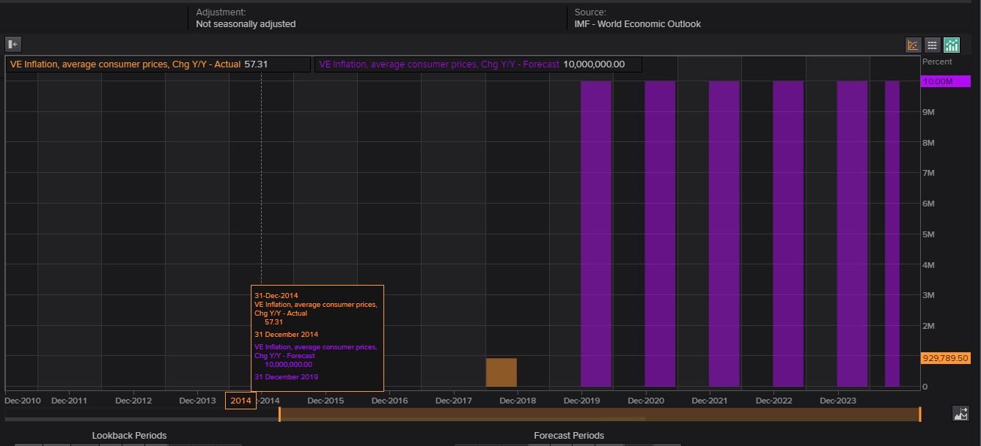

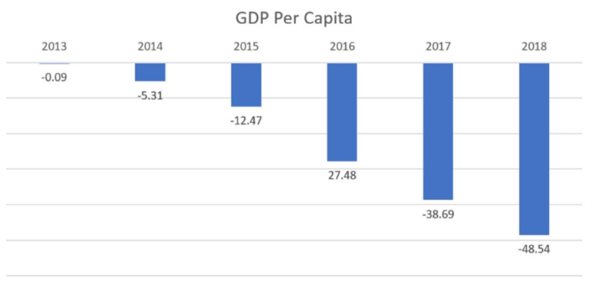

* Sanction on Venezuela oil will moderately affected Venezuela's petroleum industry, according to the New York Times, by prohibiting the trading of Venezuelan bonds in U.S. markets. The sanctions restricted the export of American light crude oil to Venezuela for mixing with its heavy crude, and financing for humanitarian services to the Venezuelan people.
* The imposed sanctions on the ([PDVSA](https://en.wikipedia.org/wiki/PDVSA)) Venezuelan state-owned oil and Natural Gas Company prevent PDVSA from being paid for petroleum exports to the US, freeze $7 billion of PDVSA's US assets and prevent US firms from exporting [naphtha](https://en.wikipedia.org/wiki/Naphtha) to Venezuela. The expected loss to the Venezuelan economy at more than $11 billion in 2019.these sanctions are expected to reduce Venezuela's ability to purchase food and other imports which could result in further shortages and worsen its economic position.

The Venezuelan National Assembly has been looking at ways to access Venezuela's overseas cash and facilities. PDVSA's US subsidiary [CITGO](https://en.wikipedia.org/wiki/Citgo) said that it would formally cut ties with PDVSA to comply with US sanctions on Venezuela, and halted payments to PDVSA. [Juan Guaid](https://en.wikipedia.org/wiki/Juan_Guaid%C3%B3)o and the National Assembly appointed a new Citgo board of directors under Chairperson Luisa Palacios. The National Assembly authorized Guaido's appointment of a new [ad hoc](https://en.wikipedia.org/wiki/Ad_hoc) board of PDVSA, CITGO, PDVSA Holding Inc, Citgo Holding Inc. and Citgo Petroleum Corporation. Even though control of PDVSA assets in Venezuela remained with Maduro, Guaido also named a new board for PDVSA. With Citgo under the control of Guaido's administration, the US Department of Treasury extended its license to operate in spite of US sanctions.

These sanctions reduced the production of oil as shown in the below charts

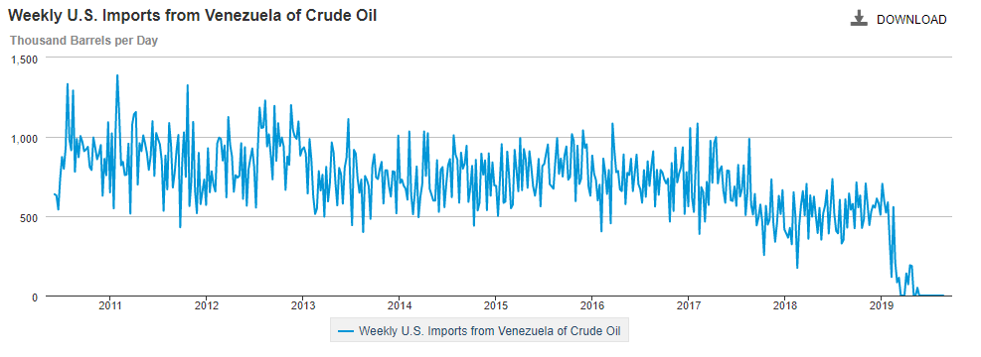

Venezuela exported about 1.06 million bpd of crude and refined products in April, up slightly from 980,000 bpd in March, according to data from Refinitiv Eikon. Exports sank 40 percent in February, the first full month after the sanctions were imposed.

|  |  |  |
| --- | --- | --- |
|  | March | April |
| China | 266,000 | 326,000 |
| India | 240,000 | 240,000 |
| Russia * | 100,000 | 220,000 |
| Others | 237,000 | 169,000 |
| Total | 843,000 | 955,000 |

The flow of Venezuelan crude to India has not fallen sharply despite pressure from the US Department of State to reduce its dependence on the sanctions-hit oil exporter. India’s petroleum secretary told US officials in March2019 the government was stressing to private Indian refiners the risks of importing Venezuelan crude amid US sanctions against PDVSA.

Reliance, which operates two mega-refineries at the Jamnagar complex on India's west coast, has said it would reduce its Venezuelan crude imports in compliance with US sanctions. Reliance also halted sales of diluent like naphtha to Venezuela. PDVSA depends on imported naphtha to dilute its heavy crude grades.

However, Indian refiner Nayara Energy's largest shareholder is Rosneft, and Russia has committed to helping the regime of President Nicolas Maduro withstand US sanctions.

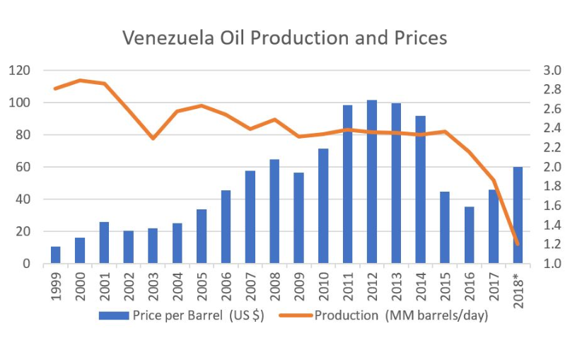

The Venezuela government is one of the richest country in South America is mainly because of the oil reserves it has but due to the collapse of oil barrel price in 2014 and political instability, corruptions in the government and dependency on oil made the country to fall into economic cries, further the sanctions on this made the country even worst. This leads the imports to reduce.

Venezuela exports mineral fuels, oils, distillation products which take 98% of total exports

EXPORTS BY VENEZUELA BY CATEGORY IS SHOWN BELOW

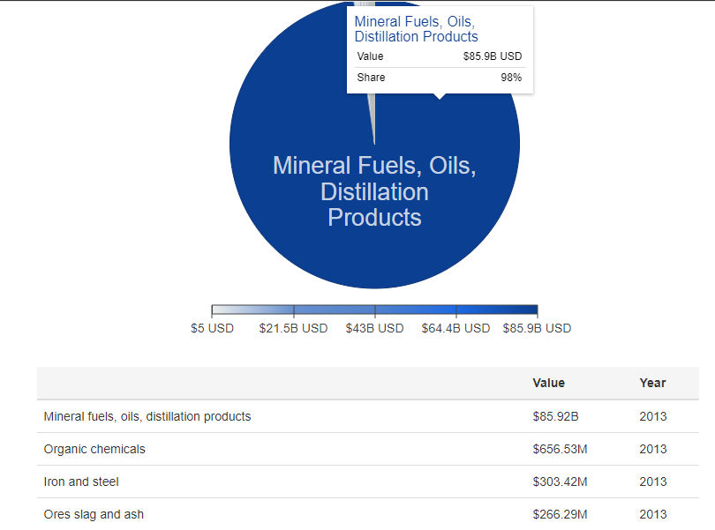

Venezuela imports about 23% and exports about 24%to US due to these sanctions the imports and exports of it decreased drastically.

**VENEZUELA IMPORTS:**

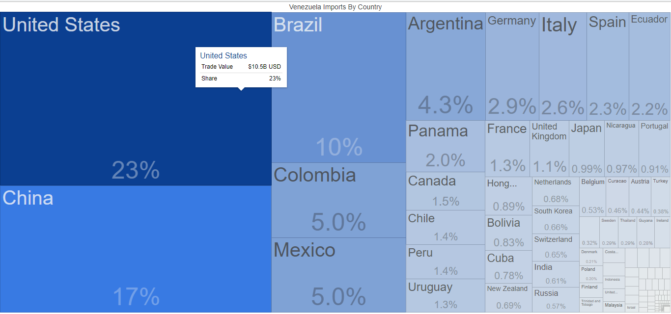

**VENEZUELA EXPORTS:**

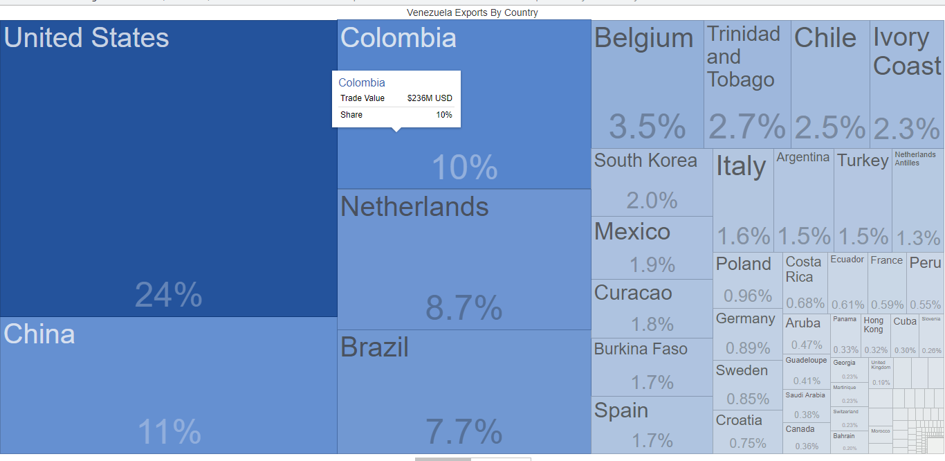

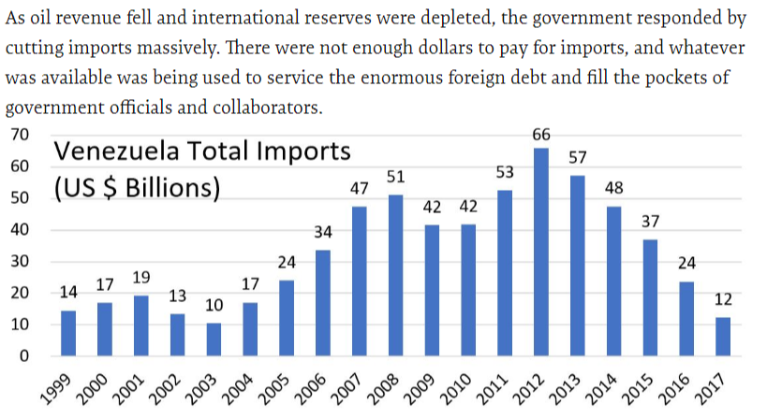

* Venezuela's third-largest export (after crude oil and refined petroleum products) is gold. The country's gold production is controlled by the military and is mined under dangerous conditions. The World Gold Council reported that Venezuela's foreign-held gold reserves had fallen by 69% during Maduro's presidency. Trump signed an executive order to ban U.S. persons from dealing with entities and individuals involved with 'corrupt or deceptive' gold sales from Venezuela.

Below is the graph showing the Venezuela gold reserves. It shows a clear indication of decreasing in the gold reserves during Maduro presidency

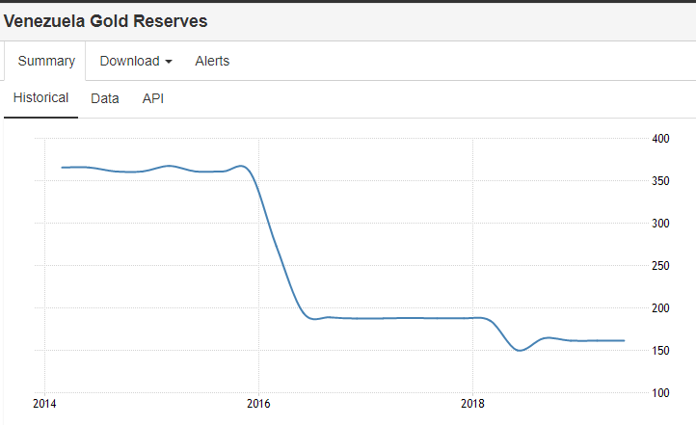

* U.S. President [Donald Trump](https://en.wikipedia.org/wiki/Donald_Trump) signed an order that prohibits people in the U.S. from making any type of transaction with digital currency emitted by or in the name of the government of Venezuela. The executive order referenced "[Petro](https://en.wikipedia.org/wiki/Petro_(cryptocurrency))", a crypto-currency.
* The U.S. Treasury sanctions to the [Central Bank of Venezuela](https://en.wikipedia.org/wiki/Central_Bank_of_Venezuela) , the United States has taken steps to ensure that regular debit and credit card transactions can proceed and personal remittances and humanitarian assistance continue unabated and are able to reach those suffering under the Maduro regime’s repression. The new sanctions will close some loopholes that allow for continued financing of the government. The Central Bank was able to obtain loans without seeking approval from the National Assembly. It also sells gold to the central banks of other countries. And by interrupting the foreign exchange handled by the Central Bank.
* The US sanctions decreased imports this affected the people in the country drastically ending country access to essential imports including medicines and food-even those that could be bought with available dollar. So as a result of this sanction it had severe impact the human life and health.

**12. IMPACT ON INFLATION: -**

* **Normal Inflation**:-Inflation is the nominal rise in prices of goods and services.
* **Hyperinflation**:-It is a rapid increase in prices of goods and services more than 50% in a month.

**Hyperinflation in Venezuela**is a period of currency instability in Venezuela that began in November 2016 during the country's ongoing socioeconomic and political crisis.

Venezuela began experiencing continuous and uninterrupted inflation in February 1983, with double-digit annual inflation rates. From 2006 to 2012, the government of Hugo Chavez reported decreasing inflation rates during the entire period.

Inflation rates increased again in 2013 under Chavez’s successor, Nicolas Maduro, and continued to increase in the following years, with inflation exceeding 1,000,000% in 2018.

In comparison to previous hyperinflationary episodes, the ongoing hyperinflation crisis is more severe than those of Argentina, Bolivia, Brazil, Nicaragua, and Peru in the 1980s and 1990s, or that of Zimbabwe during the mid-2000s.

**12.1 Lifeblood of Oil**

Venezuela’s 352,144 square miles on South America’s northern coast—located between Colombia, Brazil and Guyana—is roughly twice the size of California. The country has a population of 30 million and is rich in natural resources, including gold, minerals and crude oil.

The discovery of oil in 1914 transformed Venezuela’s agriculture dependent economy. By the mid-1920s, oil revenue supplied two-thirds of the state’s income and was responsible for more than 90 percent of exports. Oil wealth made it possible for the government to build a network of roads and infrastructure and expand its agricultural and manufacturing sectors. As the world struggled with the great depression in the 1930s, the Venezuelan bolivar appreciated nearly 70 percent against the U.S. dollars.

* As Venezuela’s economy is over-dependent upon the Oil sector, as the manufacturing sector was only contributing about 15% of total GDP in 2009, and the Agricultural sector is contributing 3% of GDP. So due to these factors, the income source of the country is mainly an oil sector, and this situation is dangerous because if that particular sector collapses the country’s economy will also collapse, and this has happened with Venezuela which is still continuing.

**FIG**:-Venezuela GDP Contribution 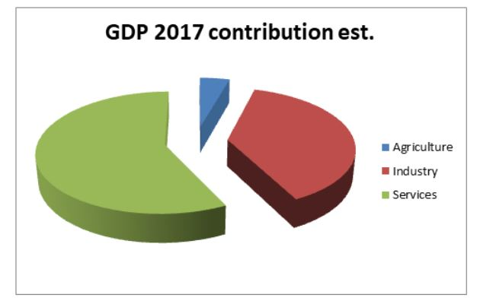

**12.2 CAUSES:-**

1. **Printing Excess Money: -** In order to control the inflation, the government start printing more money where the people are having money and they are surviving on the imported goods and the demand for the goods increases, supply is low where the price of a good increases which leads to Hyperinflation
2. **Loss of currency value: -** By 2014 the value of Venezuela’s currency, the bolivar, and the Venezuelan economy, was highly dependent on oil exports. The global price of oil dropped. Foreign demand for the bolivar to buy Venezuelan oil crashed. As the currency’s value fell, the cost of imported goods went up
3. **Falling of PDVSA: -** Petroleos de Venezuela S.A is the Venezuelan state-owned oil and natural gas company working from 1st Jan 1976 and soon after became the world’s 5th largest oil exporter company. At this peak company had produced 3.5 Million barrel of oil per day in 1998 and production fell in 2013 by 1 Million barrel per day to 2.5 Million barrel per day, and currently have approximately 90 Billion US$ in debt.

As, there is no maintenance, they sucked everything they could from PDVSA without investing, there’s nothing left to squeeze. They also employed unskilled and unexperienced people, causes the downfall of the company.

1. **Falling of oil production: -**    When it is an oil-centric economy, they need to have a look of the of their own country oil production, but it seems reverse situation in Venezuela. Oil production has seen a decline in production and estimated that it is up to 1.8 million barrel per day which is half in comparison when they start their productions.**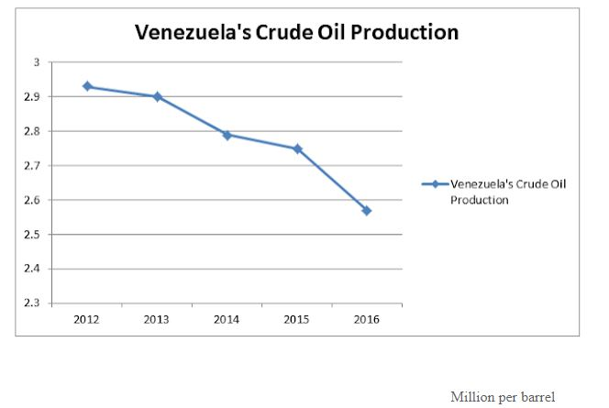Fig**:**-** Oil production which has kept on dropping and this becomes a significant factor of Venezuela’s Hyperinflation.
2. **Decreasing in the foreign reserves**:- Foreign reserves are significant to any country as they can influence the exchange prices etc. So having the foreign reserve in the country’s central bank is beneficial for the nation but Venezuela also lacks in this aspect. Many economists said that Venezuela’s foreign reserves have dropped $10 Billion. This directly affects the value of a currency, and it has shown a direct impact on the amount of Bolivar. Value is declining day by day, and it is went down compared to other foreign currency.

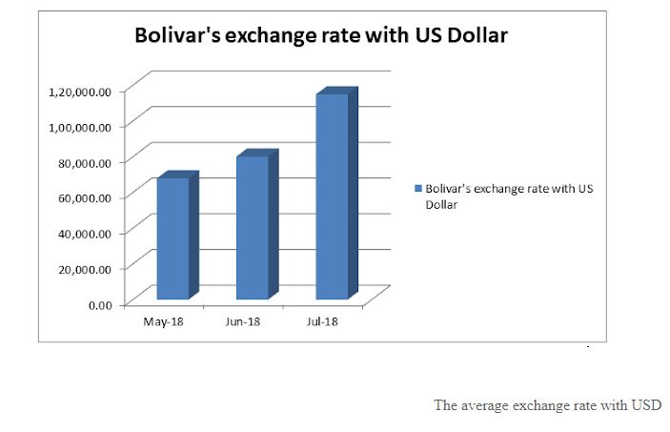

**FIG**: - Bolivar Exchange rate with US Dollar

1. **Debt problem: -**  Venezuela has a debt problem where Venezuela has about $60 Billion in bonds. That includes debt issued by the Venezuelan government as well as bonds issued by the companies such as the state oil company PDVSA. But that is not all Venezuela owes, It is total external debt, which also includes loans from countries like Russia and China which is thought to be as much as $140 Billion. Due to its crisis, many firms and country are starting to ask for repayment of their debt, and this is an additional problem faced by Venezuela.

Above are some critical factors which led Venezuela into Hyper Inflation. But the problems are not only those, there are also various problems facing by Venezuela, following are few: -

• Venezuela’s unemployment rate is forecasted to 33.35% till Dec 2018

• Caracas is a capital city of Venezuela and ranked worlds 2nd dangers city with murder rate.

• Approximately 87% of the population is poor, and 60% of those live in extreme poverty.

• In 2017 more than 27 protest per day is registered.

• Since 2015 approximately more than 8,000 people died protesting.

**INFLATION RATES**

|  |  |
| --- | --- |
| **YEAR** | **RATE** |
| **2013** | **52.8** |
| **2014** | **69%** |
| **2015** | **181%** |
| **2016** | **800%** |
| **2017** | **2,616%** |
| **2018** | **1M** |
| **2019** | **10M(IMF Estimated Value)** |

Above table indicates the inflation rates from 2013-2015, where in 2019 IMF is estimating about 10M, the ongoing hyperinflation crisis is more severe than those of Argentina, Bolivia, Brazil, Nicaragua, and Peru in the 1980s and 1990s, or that of Zimbabwe during the mid-2000s.

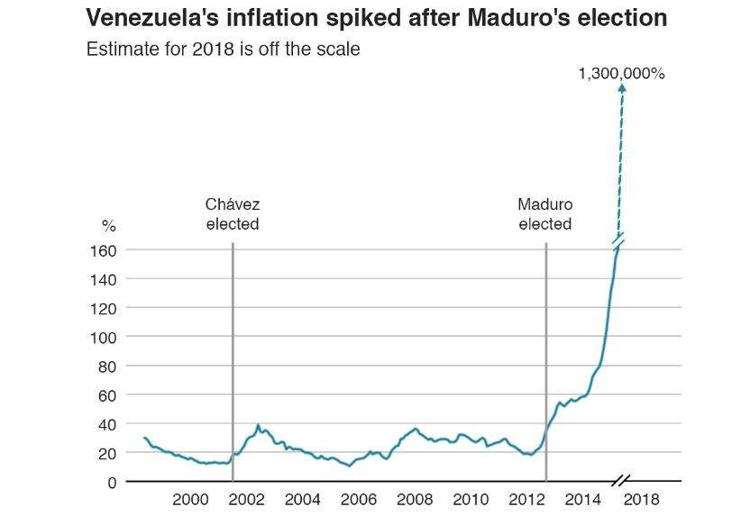

**FIG:-** Venezuela Inflation after Maduro Election

* **Price Controls and Shortages**

Venezuela’s economic crisis is marked by a longstanding lack of currency, food and other basics, increased by long-standing price and foreign exchange controls. These restrictions and the lack of investment in basic infrastructure have eradicated Venezuela’s productive capacity, making the country overly dependent on imports for its consumption. Yet, foreign currency controls have stop the ability to pay for imports. US dollars have been in short supply, the result of an oil-price collapse, which saw prices fall from$100 per barrel in mid-2014 to as low as $30 in early 2016 before moving toward $50 at year-end.

Government imposed price controls make it difficult to produce and earn a profit, so while supermarket shelves are empty, a thriving black market has developed. In March 2016, goods were more than 17 times costlier on the black market than on the conventional market. By August 2016, some goods, including staples, cost 100 times the official price. Milk sold for 7,000 bolivars—more than $700 at the official exchange rate.

* **Dealing with the Economic Crisis**

Venezuela’s economic crisis is most directly linked to the mismanagement of its oil wealth—a combination of corruption, forceful social spending and a lack of savings or investment in the oil industry. The government has been repeatedly caught unprepared when oil prices have collapsed. The quantity theory of money indicates that sustained high growth rates of a nation’s money stock in excess of its production of goods and services eventually produces high and rising inflation rates.

Venezuela responded with price controls. Such controls lead to shortages because they encourage demand at a price lower than what goods would otherwise cost. Profit margins get squeezed and shortages worsen when foreign exchange earnings, used to pay for imports. Government imposed currency and capital controls also limit access to foreign currency for imports of intermediate goods used in production, triggering additional shortages.

Consumer prices increased at an average annual rate of 40 percent in 2013, climbing to 62 percent in 2014. The pace of increase accelerated through 2015, reaching122 percent. By December 2015 inflation was at 180 percent.

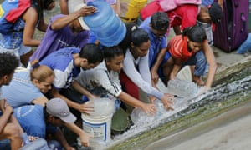 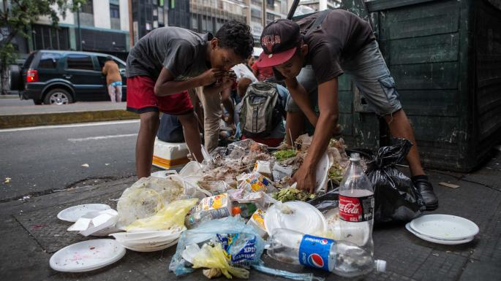

* **Capital and Currency Controls**

The Venezuelan government has maintained a system of currency controls and a fixed official exchange rate. The government makes dollars available at multiple exchange rates, allowing some companies and individuals to access dollars at preferential rates.

There have been two official exchange rates since March 2016, when the government announced its dual foreign-exchange-rate system. The first rate, known as DIPRO, replaced the CENCOEX rate and is set at 10 bolivars per $1. This fixed but adjustable rate is used for imports of government authorized priority goods, including food, medicine and raw materials for production. The second rate DICOM governs transactions not covered by the DIPRO rate and is allowed to fluctuate according to the country’s economic dynamics. The rate had an initial opening of 206.5 bolivars per $1 on March 7, 2016, and was priced at 686.6 bolivars per $1 on Jan. 26, 2017.

13. **Impact on Trade**

Venezuela is the 65th largest export economy in the world and it is founding member of OPEC. It recorded a trade surplus of 4616 USD Million in the fourth quarter of 2018. Balance of Trade in Venezuela averaged 4335.85 USD Million from 1990 until 2018, reaching all time high of 18496 USD Million in the third quarter of 2008 and a record low of -3154 USD Million in the fourth quarter of 2008.

**13.1 Exports**

In 2017 Venezuela exported $27.8B, making it the 65th largest exporter in the world. During the last five years the exports of Venezuela have decreased at an annualized rate of -22.2%, from $153B in 2012 to $27.8B in 2017. The most recent exports are led by Crude Petroleum which represent 79.8% of the total exports of Venezuela, followed by Refined Petroleum, which account for 10.3%.

The top exports of Venezuela are Crude Petroleum($22.2B), Refined Petroleum ($2.86B), Acyclic Alcohols($456M), Iron Reductions ($305M) and Iron Ore($280M) and its imports are Corn($377M), Wheat($248M), Ethers($168M) and Rice($164M)

The top export destinations of Venezuela are the United States ($11.6B), China ($6.42B), India ($5.25B), Singapore ($1.25B) and Spain ($390M). The top import origins are the United States ($3.45B), China ($1.65B), Mexico ($1.08B), Brazil ($469M) and Colombia($318M).

2013 Exports: - $144B

2014 Exports: -$63B

2017Exports:-$27.8B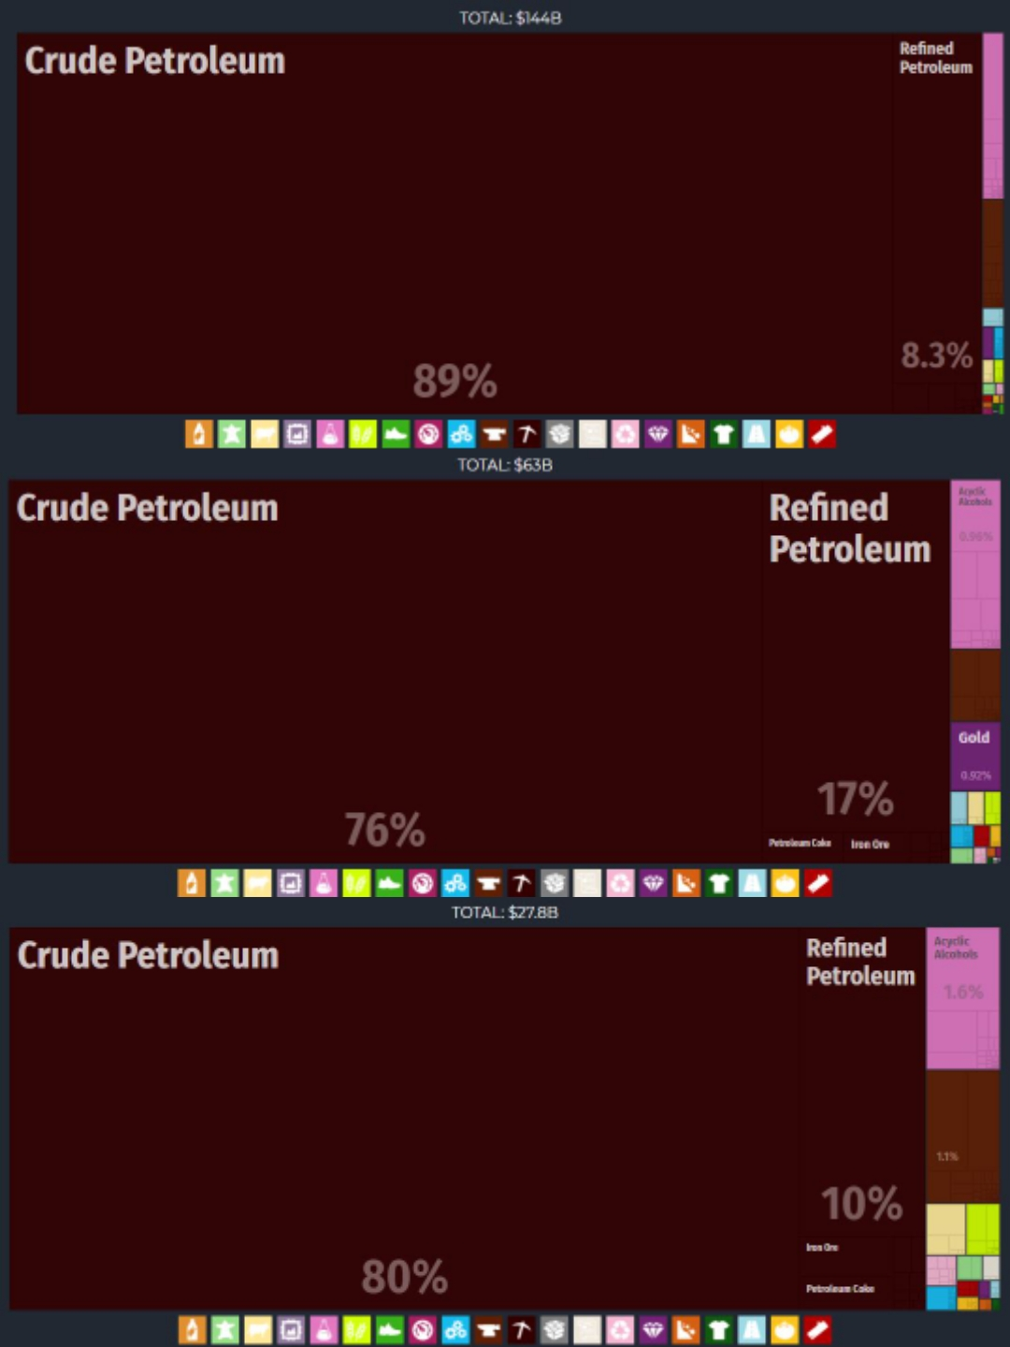

**FIG**: - Venezuela Exports Value in 2013, 2014, 2017

**13.2 Imports**

In 2017 Venezuela imported $9.1B, making it the 97th largest importer in the world. During the last five years the imports of Venezuela have decreased at an annualized rate of -31.2%, from $58.7B in 2012 to $9.1B in 2017. The most recent imports are led by Refined Petroleum which represent 21.7% of the total imports of Venezuela, followed by Corn, electronics, chemicals, agricultural products and livestock and base metals.

The top import origins of Venezuela are the United States ($3.45B), China ($1.65B), Mexico ($1.08B), Brazil ($469M) and Colombia ($318M).

2013 Imports: -$44.5B

2014 Imports: - $36.6B

2017Imports:-$9.1B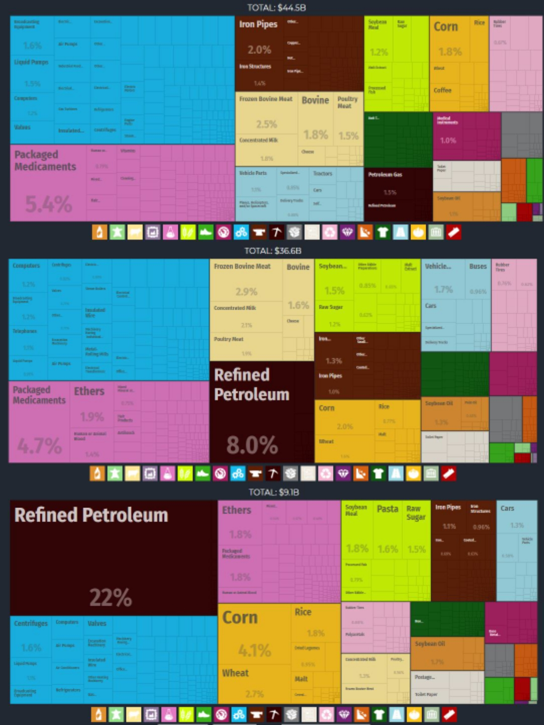

FIG: - Venezuela Imports value in 2013, 2014, 2017

**13.3 Trade Balance: -**

Trade balance is the value of exported goods minus the value of imported goods. A positive trade balance signifies a trade surplus, while a negative value signifies a trade deficit.

## Venezuela recorded a trade surplus of 4616 USD Million in the fourth quarter of 2018. Balance of Trade in Venezuela averaged 4335.85 USD Million from 1990 until 2018, reaching an all time high of 18496 USD Million in the third quarter of 2008 and a record low of -3154 USD Million in the fourth quarter of 2008 which is due to shipments of oil (96 percent of total exports). Main imports are: electronics, chemicals, agricultural products and livestock and base metals. Main trading partners are: United States (40 percent of total exports and 26 percent of imports) and China (11 percent of exports and 15 percent of imports). Others include: Brazil, India, Cuba and Colombia.

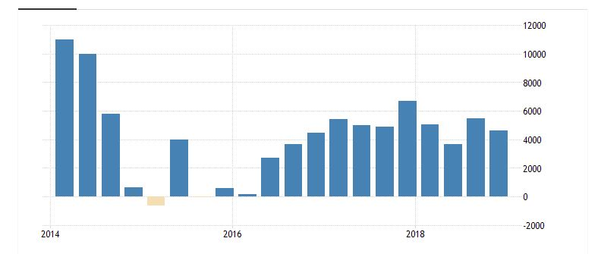

**Fig**: - Venezuela Balance of Trade in USD Millions

**14 Impact on Growth Rate: -**

The biggest sector of Venezuela´s economy is services. Financing, insurance, real estate and business services; communication, transport and warehousing; trade, repairs, restaurants and hotels; community, personal, household and government services account for 60 percent of the GDP. Manufacturing and mining create 16 percent of the wealth and oil exploitation 12.3 percent. Construction and water and electricity distribution account for the remaining 12 percent of GDP.

With the 2007 rise in oil prices and rising government expenditures, Venezuela's economy grew by 9% in 2007. Oil prices fell starting in July 2008, resulting in a major loss of income. Hit by a global recession, the economy contracted by 2% in the second quarter of 2009, contracting a further 4.5% in the third quarter of 2009. On 17 November, the Central Bank reported that private sector activity declined by 4.5% and that inflation was averaging 26.7%.

The year 2010 Venezuela still in recession as GDP has fallen by 5.8% in the first quarter of 2010. The Central Bank of Venezuela has stated that the recession is due largely "to restricted access to foreign currency for imports which lower internal demand and electricity rationing". The oil sector's performance was also particularly troubling, with oil, GDP reduced by 5%. The Central Bank hints at the root cause of the oil contraction, saying that "it was due to falls in production, operative problems, maintenance and the channeling of diesel to run thermal generators during a power crisis". While the public sector of the economy has fallen 2.8%, the private sector has dropped off to 6%.

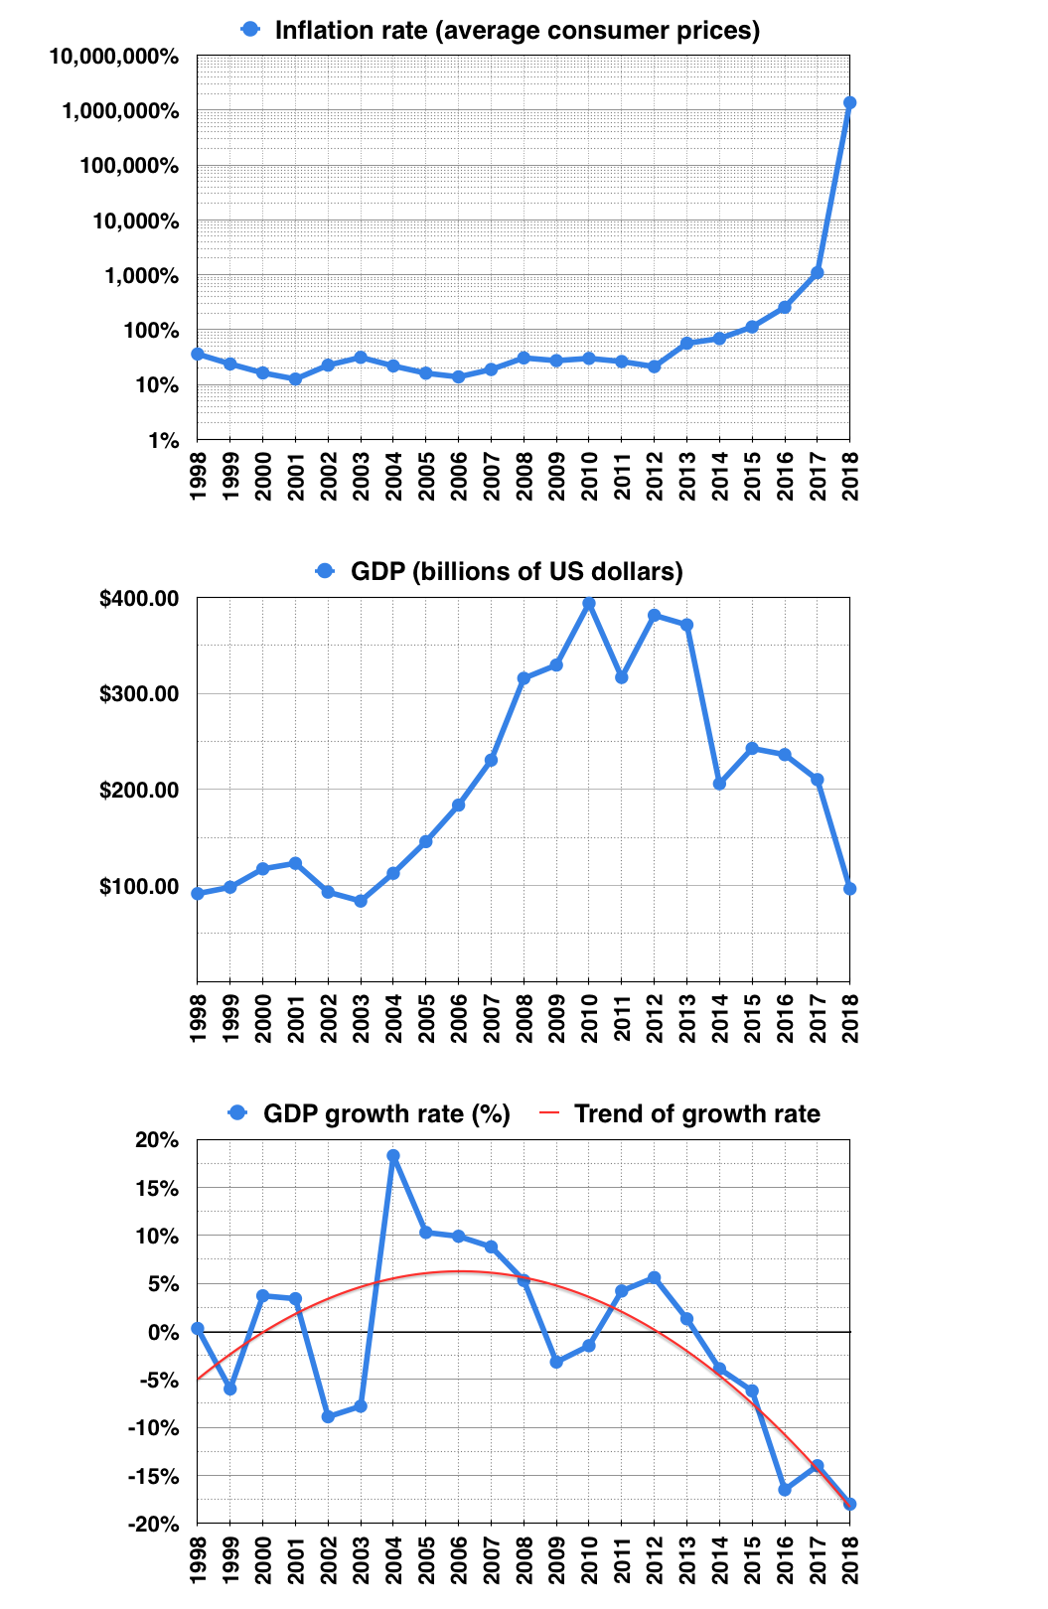 **Fig**:- Venezuela Annual GDP Growth Rate, Inflation Rate

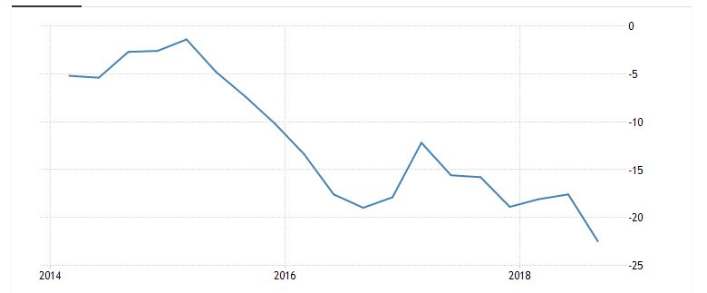 **FIG :-** Venezuela Inflation, GDP, GDP Growth Rate

**14.1 SOLUTIONS AND ADAPTATIONS: -**

* Require banks to hold a higher percentage of their assets as cash and to lend a lower percentage
* Raise interest rates on loans to banks to "above market" levels
* Raise taxes
* Reduce government spending
* Reduce the production of currency (coins and printed bills)

**15. HOW VENEZUELA IS OVERCOMING THESE SANCTIONS:**

* The Venezuela is strengthening its alliance with countries such as China, Russia, Cuba, Turkey, Palestine and Iran.
* Venezuela wants Russia to help to restructuring its debt; sanctions were hurting the whole population due to insufficient foreign currency for medical imports. Aid agencies including the international committee of Red Cross (ICRC) are bringing help and Russia provided 26,000 tons of aid including medication.
* There are strengthen bond with Russia regarding purchase of medication, they even want to invest in Venezuela for further production of medication.
* In February Maduro ordered PDVSA to move its European office to Moscow to protect PDVSA's overseas assets from US sanctions. The Russian state-run oil company [Rosneft](https://en.wikipedia.org/wiki/Rosneft" \o "Rosneft) has supplied naphtha to Venezuela and continues to purchase Venezuelan petroleum which it says is through contracts that were in place prior to the US sanctions. Exports of Venezuela's heavy crude oil depend on diluents that were imported from the US before sanctions; Rosneft chartered a ship to load thinners from Malta and deliver them to Venezuela.
* China increased its crude oil exports from Venezuela, while Venezuela oil exports to china averaged 233,000bpd in February 2019, immediately after the US sanctions cut off Venezuela oil from US market, those exports to china nearly tripled to 650,000bpd. These trading are based on oil for loan agreement and has to repay those with oil with China National Petroleum Corporation. (CNPC).
* Venezuela Secures New Chinese Oil Investment: The Venezuelan government has announced the expansion of Chinese investment in the country’s oil industry, with the aim of increasing production by 120,000 barrels per day. The investment, which authorities say is worth US [$3 billion](http://www.minci.gob.ve/inversion-china-venezuela-compromete-mas-de-3-000-millones-en-el-sector-petrolero/), financed the construction of a new oil blending plant.

**16.AUSTERITY MEASURES**

It is an official action taken by a government to reduce the amount of money it spends, or the amount of money that people in a country spend. These harsh steps are taken to lower budget deficits and avoid a debt crisis.

**1. Increase in taxes**

The government may raise taxes to increase its revenue. It can then use the additional tax revenue to reduce its debt. The government can choose to increase either the rate of direct taxes (income tax, wealth tax) or the rate of indirect taxes (consumption tax).

* Raise income taxes, especially on the wealthy.
* Target tax fraud and tax evasion.
* Increase value-added taxes

**2.  Decrease in government spending**

The government may decrease its spending. The reduction in expenditure can be used to lower the level of government debt.

**3. Change in Government Programs**

* Extend the eligibility age for retirement and health care benefits.
* Reduce government employees, wages, benefits, and hours.
* Increase worker’s hours.

**CONCLUSION**

**HOW CAN THE VENEZUELA GOVERNMENT STOP HYPERINFLATION:?**

FULL DOLLARIZATION :( ZIMBABWE)

Stopping a hyperinflation is not simple. It requires institutional and political stability; which

Venezuela currently does not have. Because dollars have now partly replaced the bolivar as

Venezuelans’ currency of choice – when and if they are able to receive them – creating a new

currency to replace the beleaguered one will be very hard. For this reason, some countries that

have battled hyperinflations have chosen to fully dollarize their economies once political and

institutional stability had been stored. This is what Zimbabwe did after a severe bout of

hyperinflation in 2008.

Full dollarization, however, has its drawbacks. When a country gives up its own currency to

use the dollar, it forgoes the ability to conduct monetary policy, which can be a very important

economic stabilization tool in the future. When a country has fully dollarized, it becomes

subject to the whims of the Fed – if the U.S. central bank raises interest rates, monetary

conditions will be tightened both in the United States and in the country that has decided to

dollarize. If that country is facing a recession, it would have been better served by loose, not

tight, monetary policy. Additionally, dollarized countries do not have control over their

exchange rates because they no longer have their own currencies. Therefore, if they would

like to devalue to boost their exports, they are unable to do so.

To avoid the pitfalls of full dollarization, Venezuela may have other options. And this is

where Brazil’s experience in 1994 may prove instructive.

INTRODUCING VIRTUAL CURRENCY:

Brazil at the time had been dealing with two decades of very high inflation, peaking in 1993

at around 2,500%. For the same reasons outlined above, Brazil decided it would not dollarize.

Instead, it chose to reform its monetary system in a very broad and ingenious way – an

initiative known as the Plano Real, or the “Real Plan.”

First, Brazil needed to find a solution to runaway fiscal deficits. Because the country had been struggling with hyperinflation for so long, politicians were amenable to approving deep fiscal reforms that would put an end to years of money printing to finance debts and deficits – this was phase one of the Real Plan.

Phase two – and this is where things get a bit complex – was the creation of a virtual currency

dubbed the URV, or “Unidade Real de Valor” (“real unit of value”). The URV was not an

actual bank note, but a unit of account: From the time of its creation, all prices in stores, supermarkets and so on were required to list prices in URVs. However, since there were no actual URVs in circulation, people would pay for goods by converting URVs into their holdings of the previous currency – then the “Cruzeiro real.” The rate of conversion of URVs into Cruzeiros reais would change on a daily basis according to market forces.

The idea was that prices in URVs would remain relatively stable on a monthly basis while prices in Cruzeiros reais were still rising. It was a kind of transitionary tool that recognized hyperinflation was just as much a behavioral problem as an economic one, and therefore it could not be stopped overnight. Fernando Henrique Cardoso, the finance minister who oversaw the design of the Real Plan and later became president, later called the URV a “sleight of hand… The public had to see that prices were leveling out over time before they would believe in any new currency.” Indeed, as time went by, people became accustomed to the idea that hyperinflation was a “Cruzeiro real problem” but not a URV problem – fiscal conditions had been set to guarantee the stability of prices in URV and there was no more irresponsible printing of money.

Once enough confidence in the URV had been established, phase three of the Real Plan went into effect: The Cruzeiro real was extinguished, and the URV became the real, which is Brazil’s currency to this day. The ingenuity of the Real Plan was to combine deep reforms to fiscal and monetary policies with an understanding of behavioral factors influencing trust in a given currency – at first the URV, a virtual currency at a time when virtual currencies were practically unheard of. The plan was a success, as inflation fell from monthly rates of 45% in March and April 1994 to just 2% in July, the month the real was launched. Inflation in Brazil has been mostly in single digits ever since.